Primo Release Notes Summary

May 2018 (released for DALNET on June 3, 2018)
- Articles will now have an open access indication:
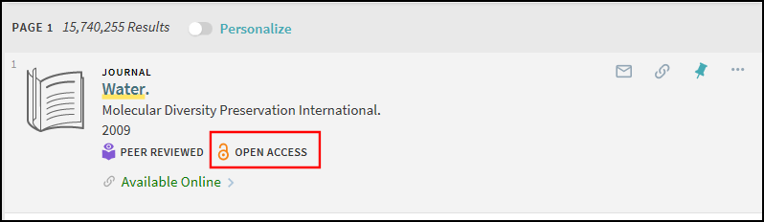
- Open Access will also now be a facet:
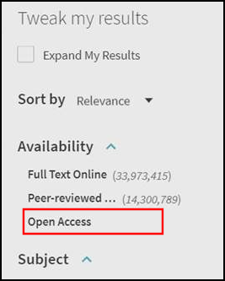
Note: These are enabled by default, but the labels may be edited in the Back Office.
- A Resource Recommender Enhancement makes it so that users no longer have to enter an exact phrase search to receive recommendations. See chart below for how these changes work:
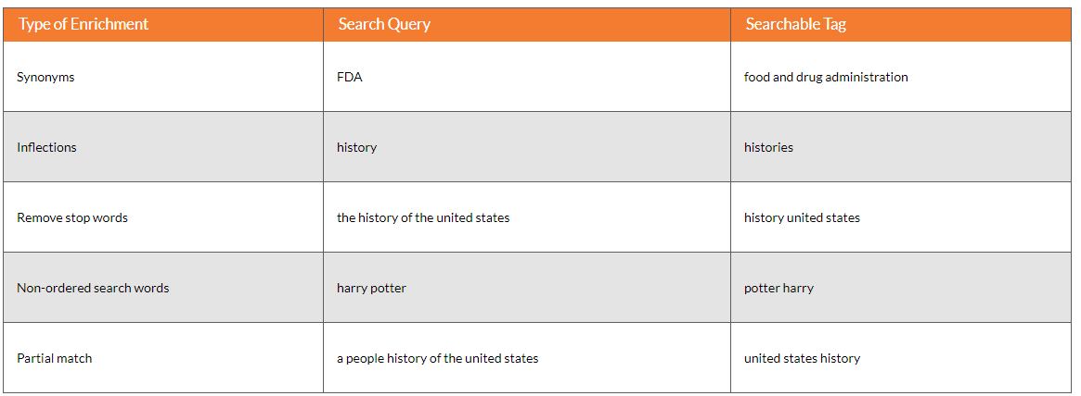

- Primo will allow users to specify the following parameters to filter their results prior to performing a basic search: resource type, search operator, and search target field. When switching to the advanced search, the system retains the pre-filters:
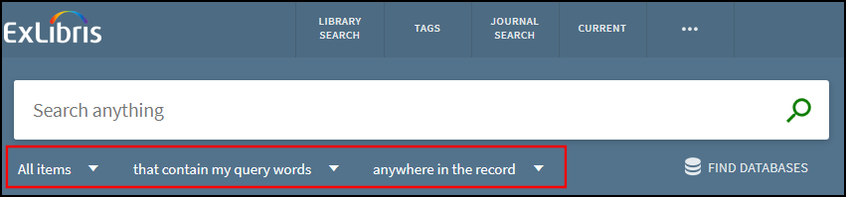
- A new Newspaper Search interface has been added.
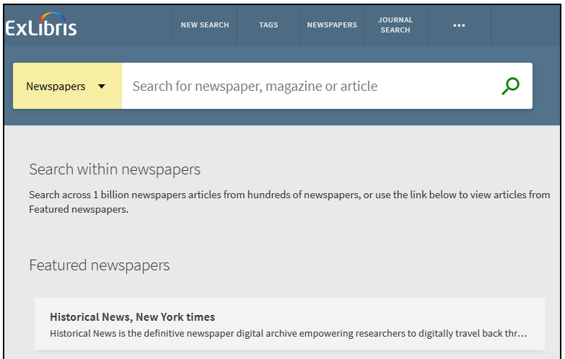

- Improved feedback messages (“show expanded results,” “no results found,” etc.) that came with February release.
- Library Records from the new Primo UI can now be made visible on the Web using the Primo Sitemap Tool, which generates (per given search scope) deep links to relevant records and creates robots.txt files for use by search engines crawlers. For more details, see Generate Sitemap Tool.

Note: The Primo May 2018 Release Highlights webinar from Ex Libris is available here: https://youtu.be/dk4bE1tFNCI.

