How to Withdraw Items from MeLCat in Alma
Change item policy to “Withdraw from MeLCat”

Search for Physical Item:
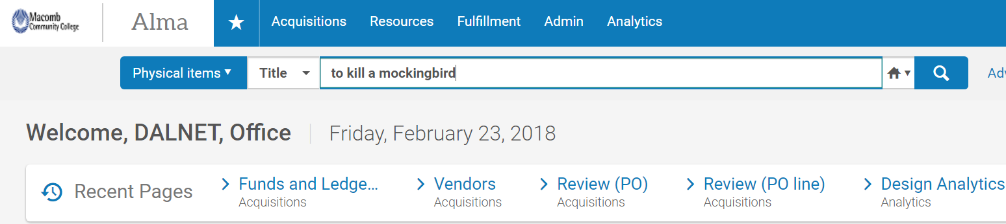

Click on Edit Item:
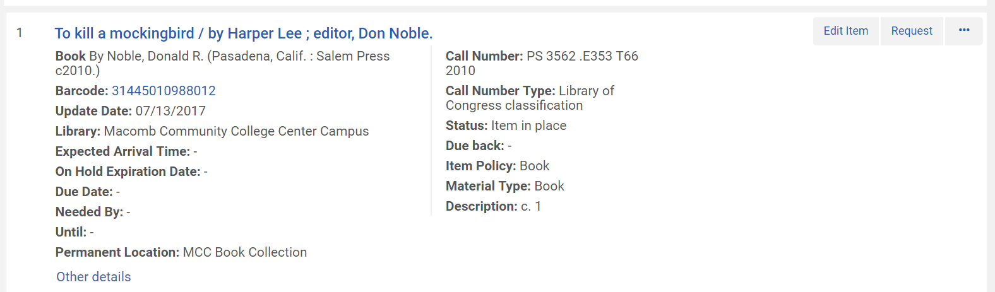

In Item Policy Click on Drop-Down Box: 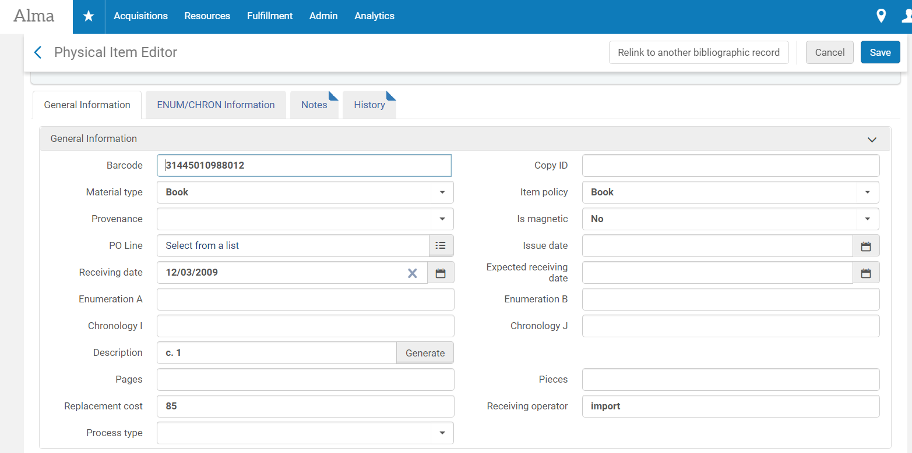

Select Withdraw from MeLCat as Item Policy and then Click Save:

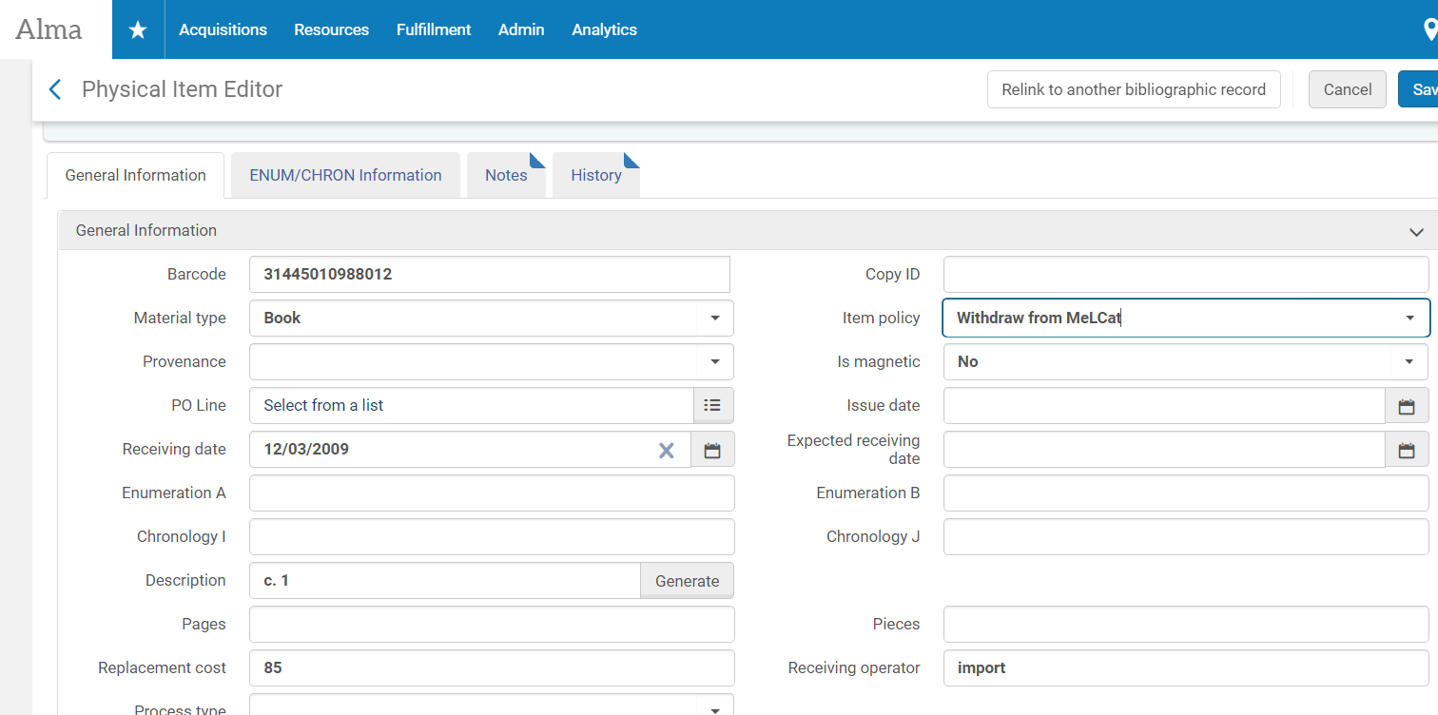

A message will say that the data has been successfully changed:
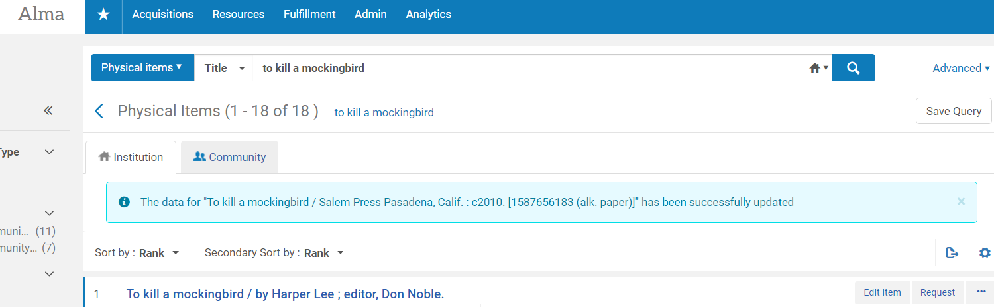

You should wait at least 24-48 hours to run a job to withdraw the items, to ensure that the item updates are sent to MeLCat before they are deleted from Alma. You may run a job to withdraw items immediately after the waiting period, or you may wait and accumulate items over a period of time and run the job to withdraw the items on a schedule, such as weekly or monthly.

If you chose to accumulate them over a period of time, you will need to locate all the items with the proper status.

To locate all of the items with the status of Withdraw from MeLCat:

In Alma, select Physical Items and then Click on Advanced:
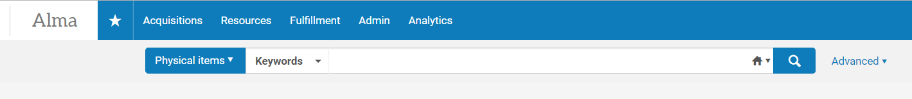

The Advanced Search Box will appear. Click on Equals and then Select Withdraw from MeLCat. Make sure you are in the Institution Zone and not the Community Zone. Click Search:
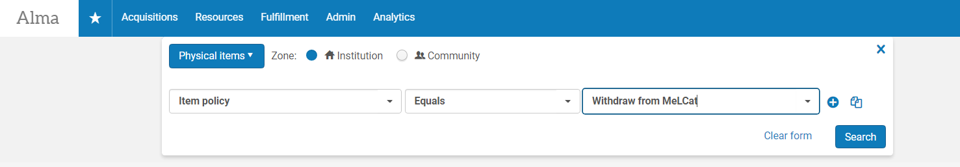
The search result has 2,179 items with the item policy of Withdraw from MeLCat. Click on Save Query:
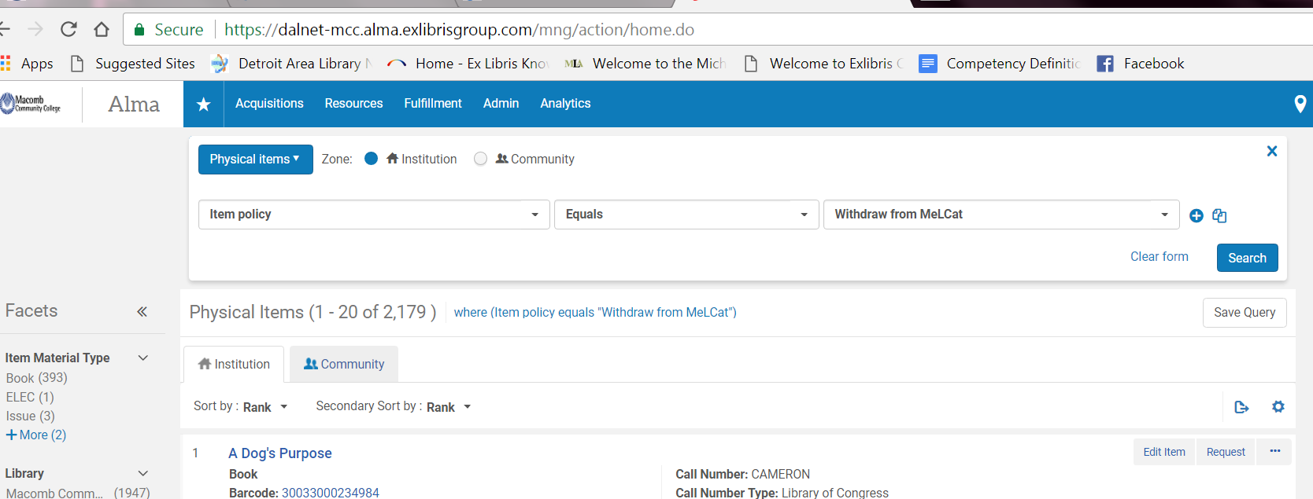

IMPORTANT NOTE:
At this point you may also wish to save this search in Excel format because once the withdraw job runs the information in the set will be deleted. Click on Export List Icon:
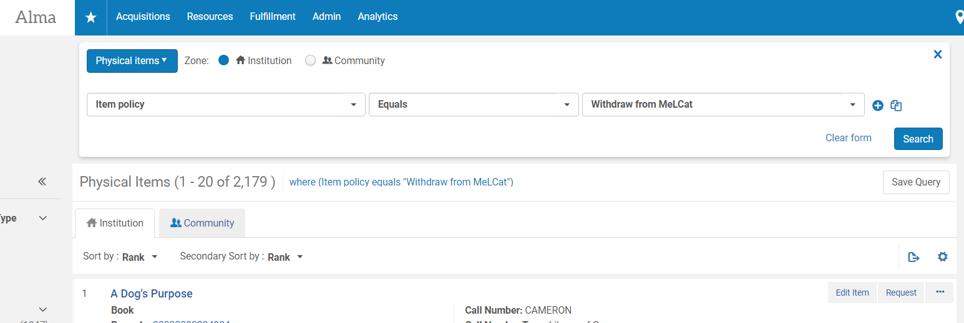

You will see this processing box:
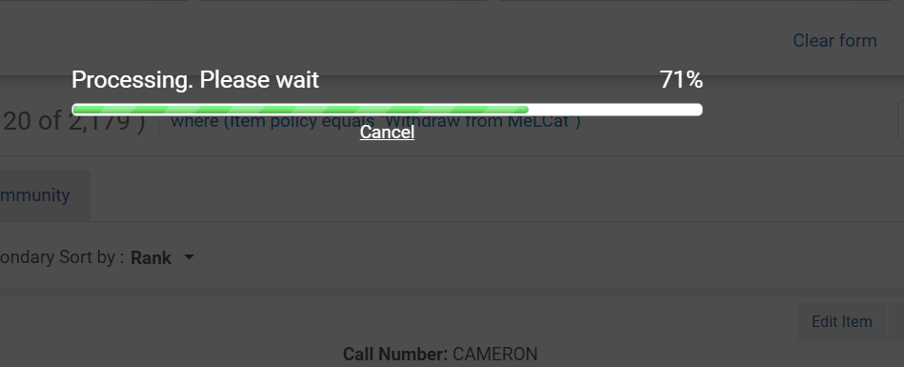

Open the Excel Spreadsheet and manipulate the data as needed:
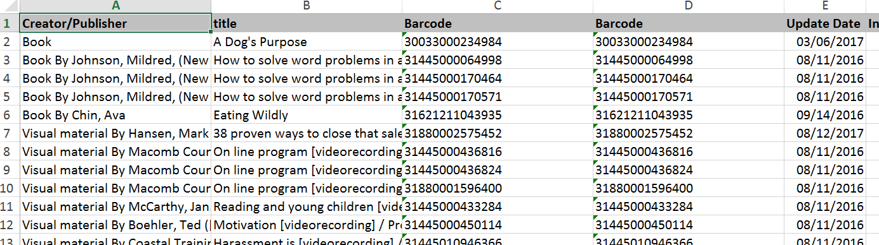

After clicking on Save Query the Set Details Box will appear. Enter a Set Name. Click Save. We recommend putting the date you ran the query for future reference. If you wish others to see the set select “No” under Private:
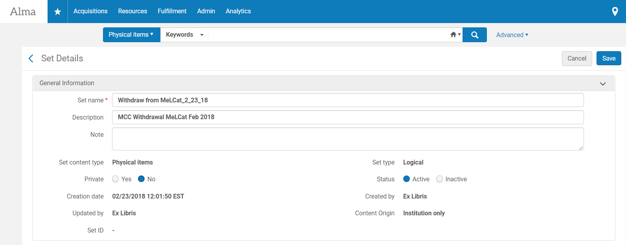

The Set is Saved:
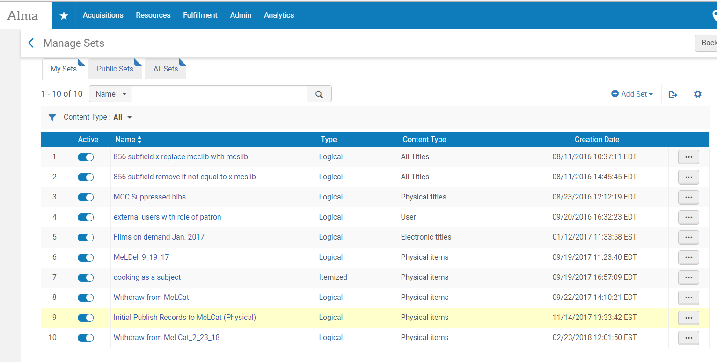

Now that you have saved your Query as a Set, you may run a Job on the Set.
In Alma Click on Admin > Manage Jobs and Sets > Run a Job:
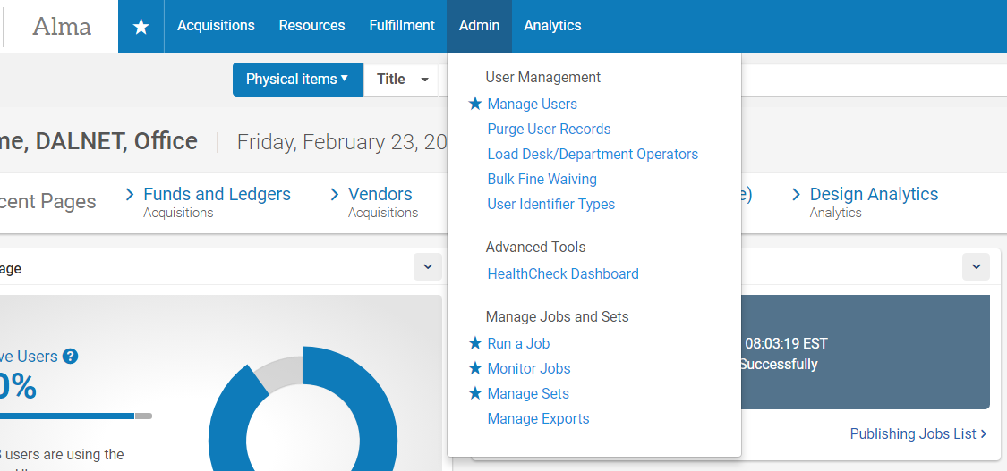

To find the job in a long list, click on the Name drop-down box and type withdraw”
Click on Search icon:
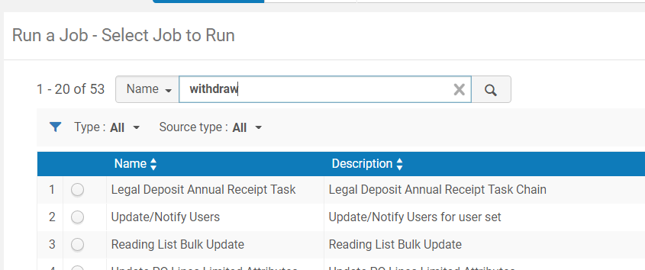
Select Withdraw Items and Click on Next:
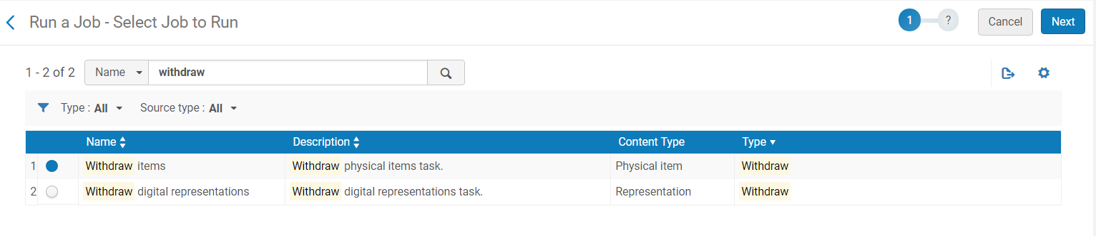

In drop-down box select Name and enter melcat. Click Search:
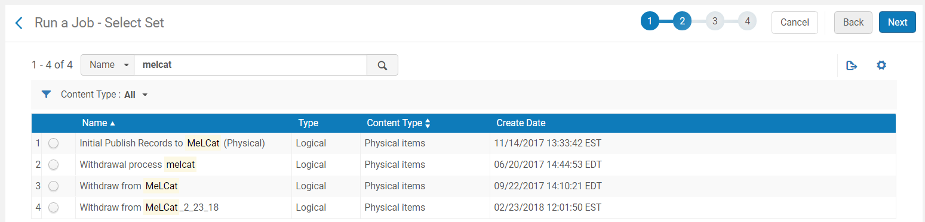

Select the Proper Set and Click on Next:
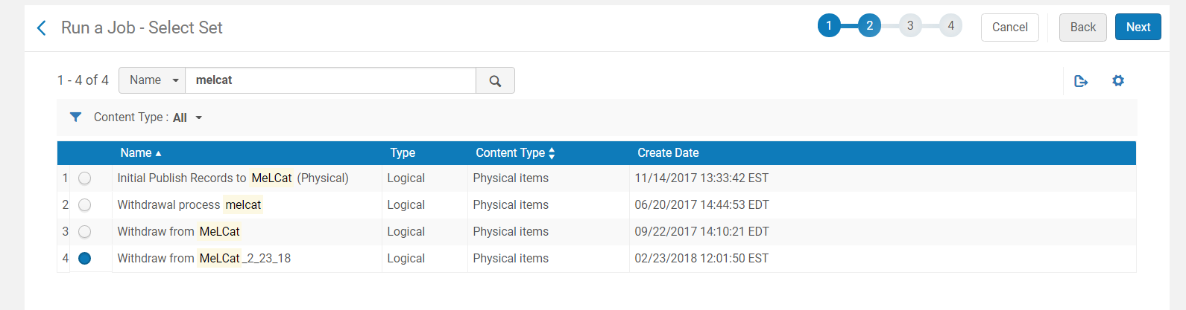

Further information is located below this screenshot which explains the various choices in this table. Most likely the “Delete holdings; delete bibliographic records that have no other holdings” will be your selection. After the selection click on Next:
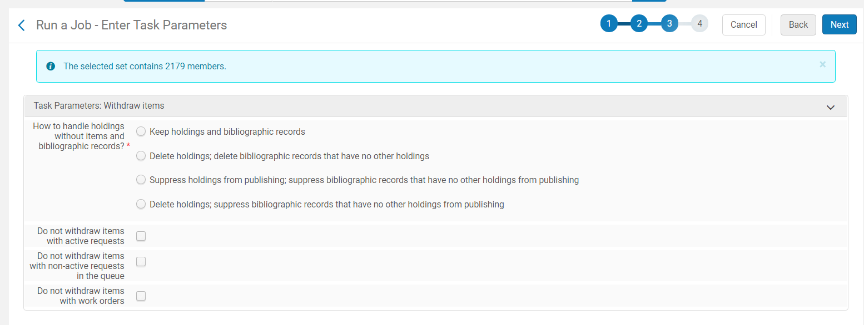

Below is from Ex Libris Knowledge Center, Running Manual Jobs on Defined Sets: https://knowledge.exlibrisgroup.com/@api/deki/pages/33393/pdf/Running%2bManual%2bJobs%2bon%2bDefined%2bSets.pdf?stylesheet=default
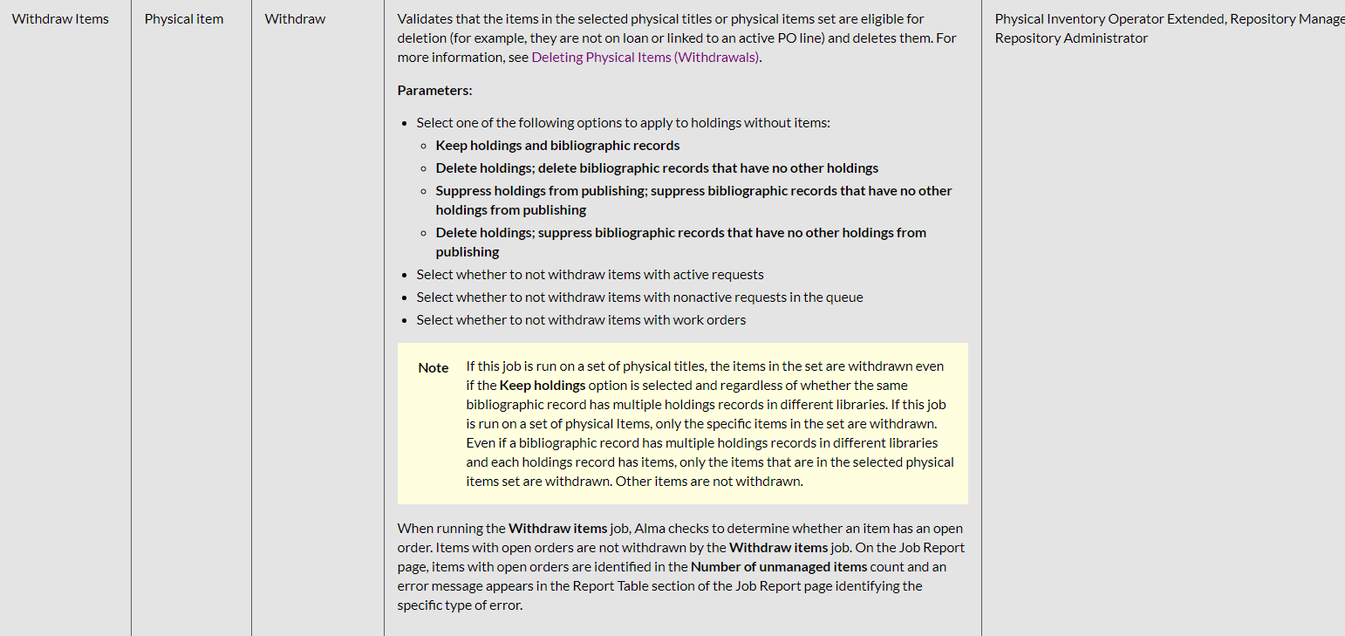

You will see a Review and Confirm screen. Double check the information and if correct, click Submit:
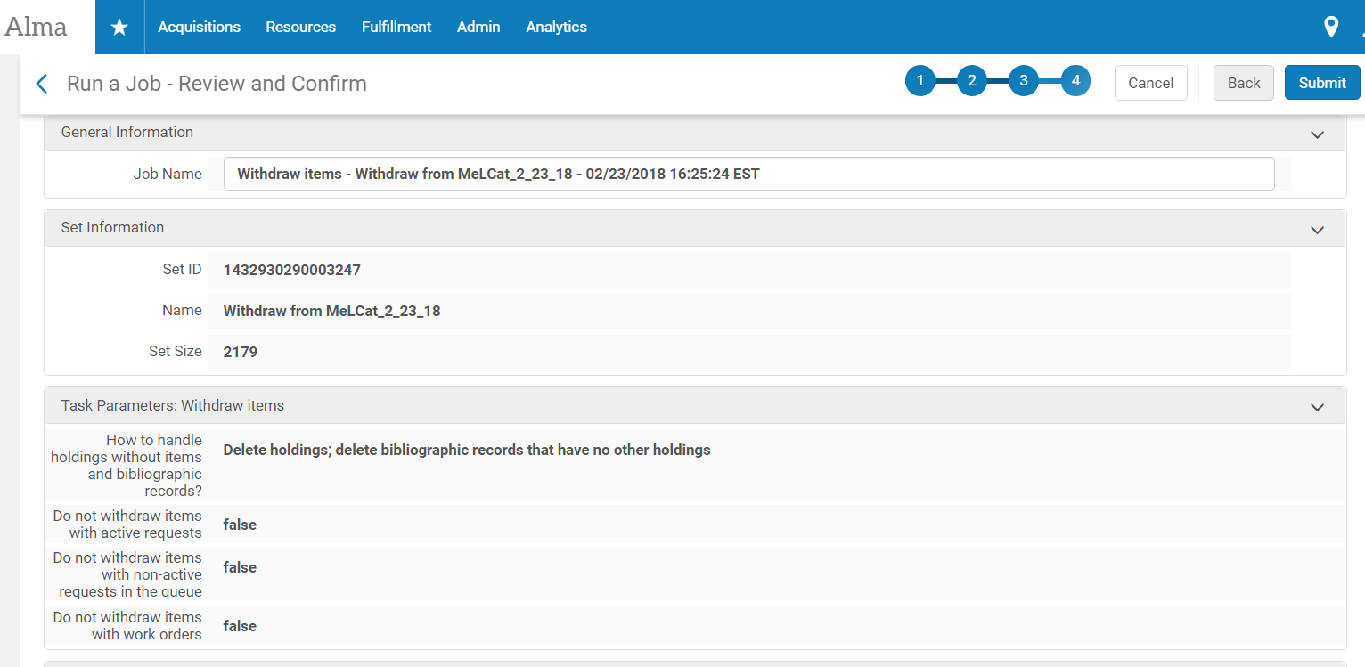

The job will run. Go to Admin > Monitor Jobs > History tab then click on icon 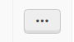
This will open up the Reports for you to monitor if it ran successfully or with errors.

