Instructions for retrieving MeLCat Statistics

- Go to https://members.mcls.org/melcat_wiki/index.php.
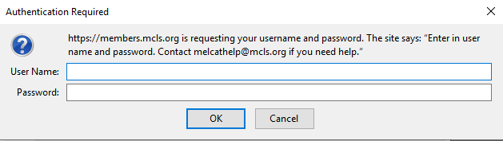
2. Log in to the wiki.

User Name: melhelp
Password: mlum2s
- Scroll down to Statistics and click Statistics Overview.
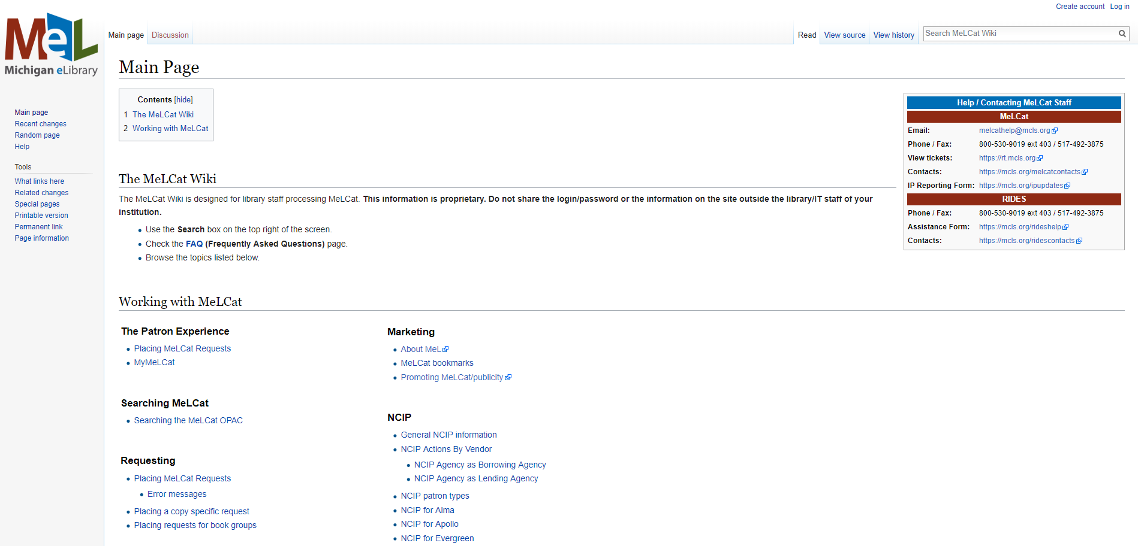

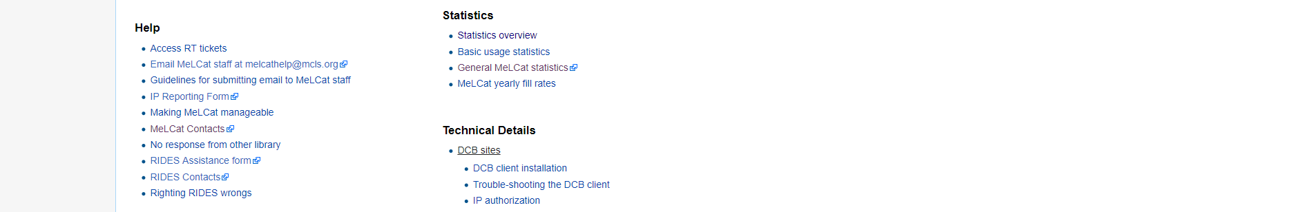

4. Click on the month you want statistics for. Each month has stats for Fulfillments and Requests.
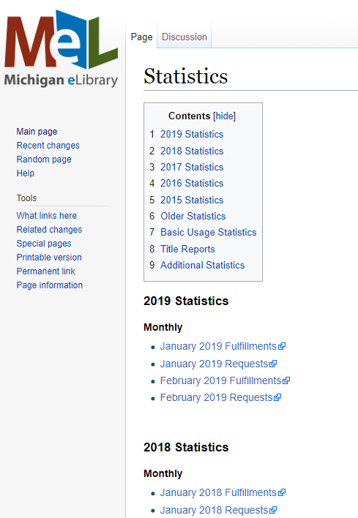

- For this example, I clicked on January 2019 Fulfillments. An excel spreadsheet will download. Open the spreadsheet.
- Look for your library code in Column A. In Column C, you will see your total items lent for that month.
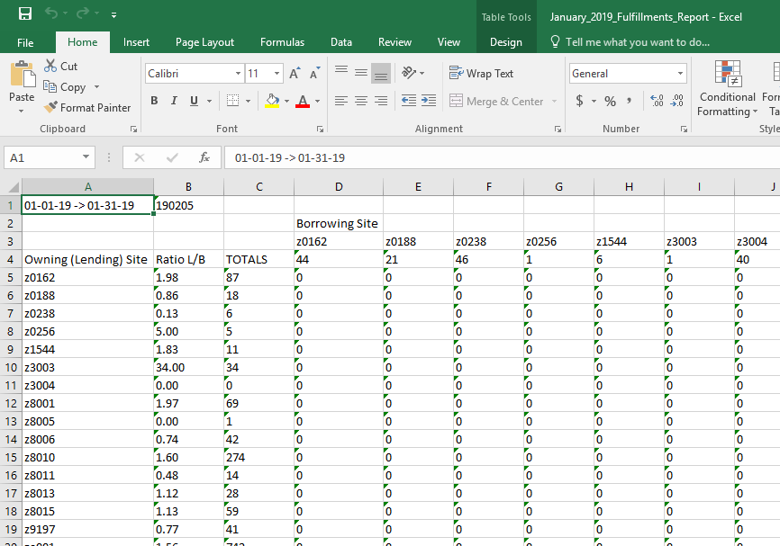

7. Look for your library code in Row 3. In Row 4, you will see your total items borrowed for that month.

8. Repeat Steps 4-7 to continue looking at each month you want statistics for.

kae/3-2019

