Disabling Individual User and User Group Email Notices

Deactivating Notices for an Individual Patron Account

Click on Admin > Manage Users:

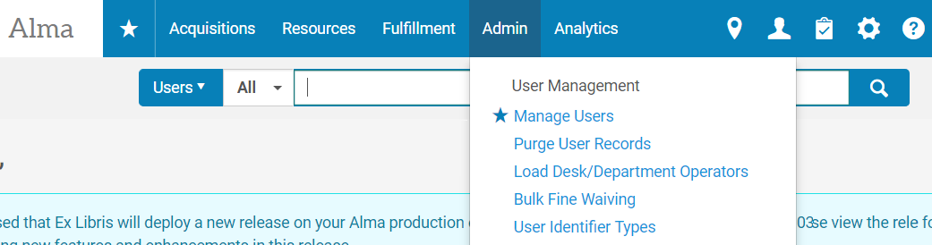

Click either the patron name or the . . . to Edit the patron record:

Click on the Selected Patron Letters to see a list of letter types received:

Select/Deselect any or all of the Patron Letters appropriate for the patron and Save:

Note: It can also be effective to remove the patron’s email if no notices are desired but this is not recommended, nor is it possible for externally managed accounts, e.g. accounts that get loaded from your external campus system.

Deactivating Notices for an Entire Patron Group

Click on the Alma Configuration “gear” icon in Alma:

Search for and click to edit the Overdue and Lost Loan Profile:

Click to Add, Edit, or Duplicate a profile:

Configure as desire and Save:
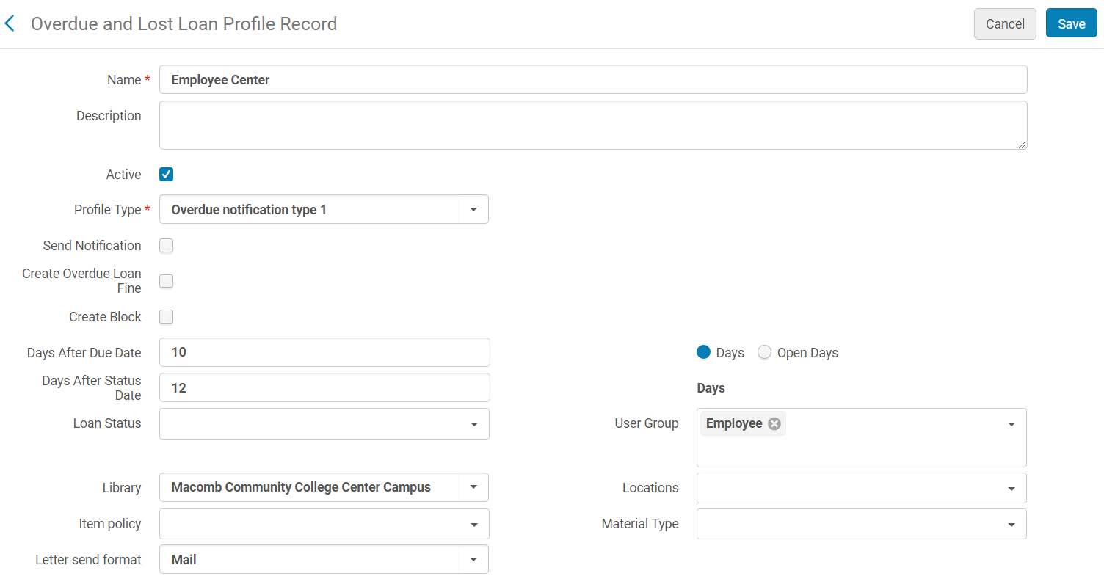

Note: If there are no entries in your Overdue and Lost Loan Profile List then no notices will be sent to anyone. If there are notices that only list specific a specific User Group, only that User Group will receive notices.

DALNET 2/2018

