Alma
To automatically pop call number into holdings record:

A new bib record in the Metadata Editor without Holdings or Items, first click the Save icon:
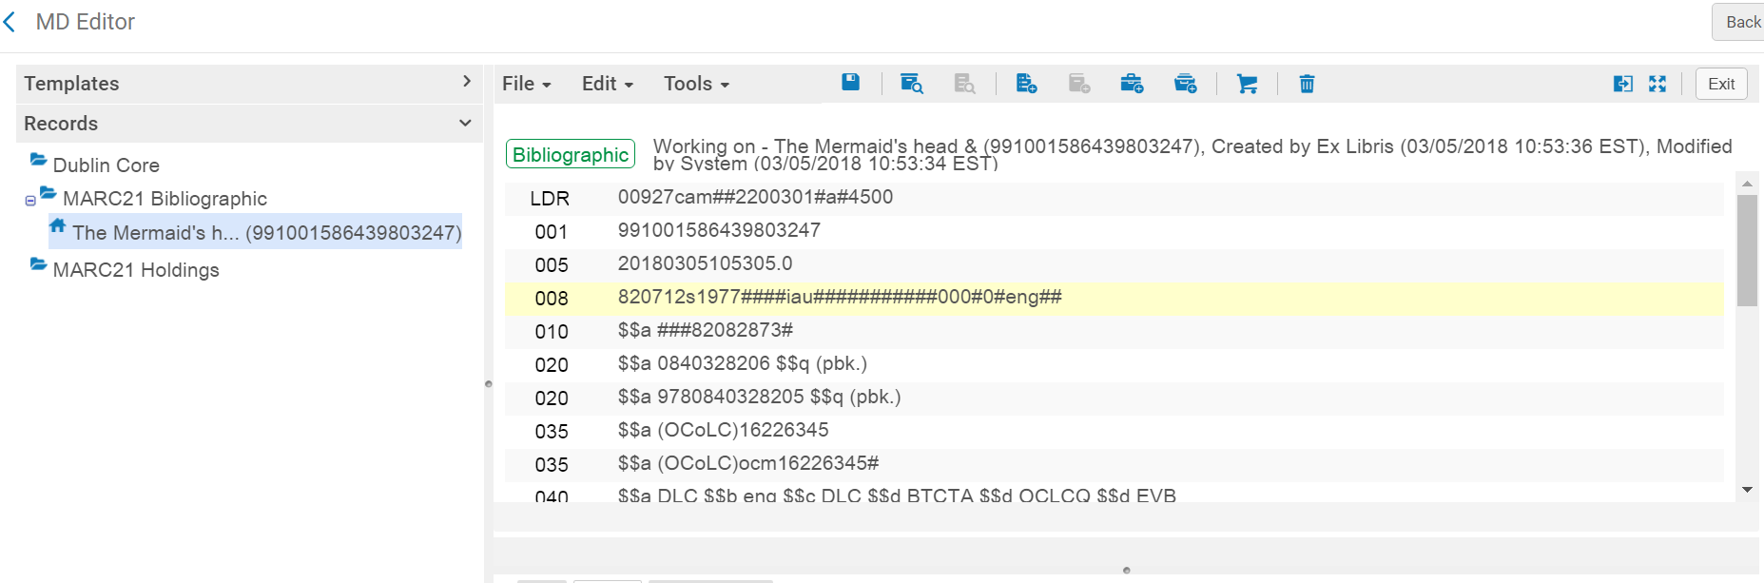
Click on Add Holdings Icon or Cntl+Alt+H:
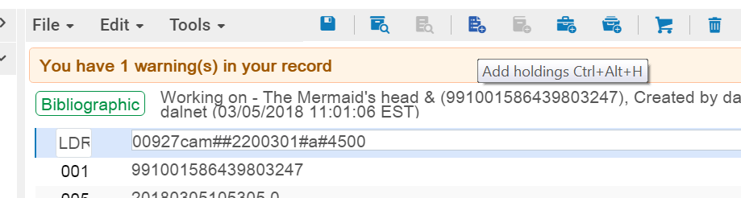
Holdings Record Opens:
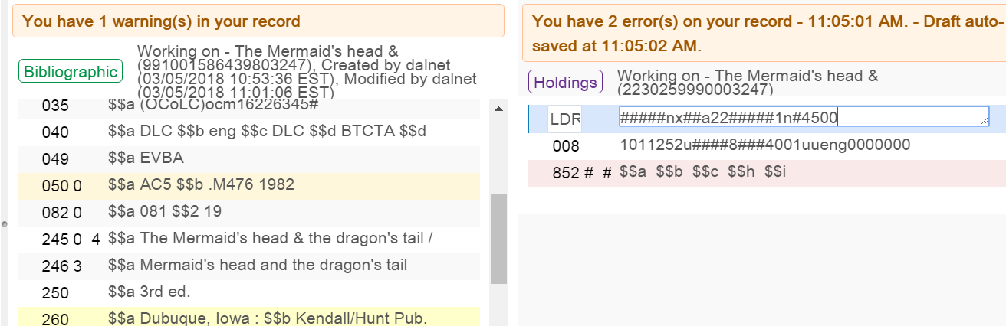

Click on Tools > MARC21 Holdings > Update from Bibliographic:
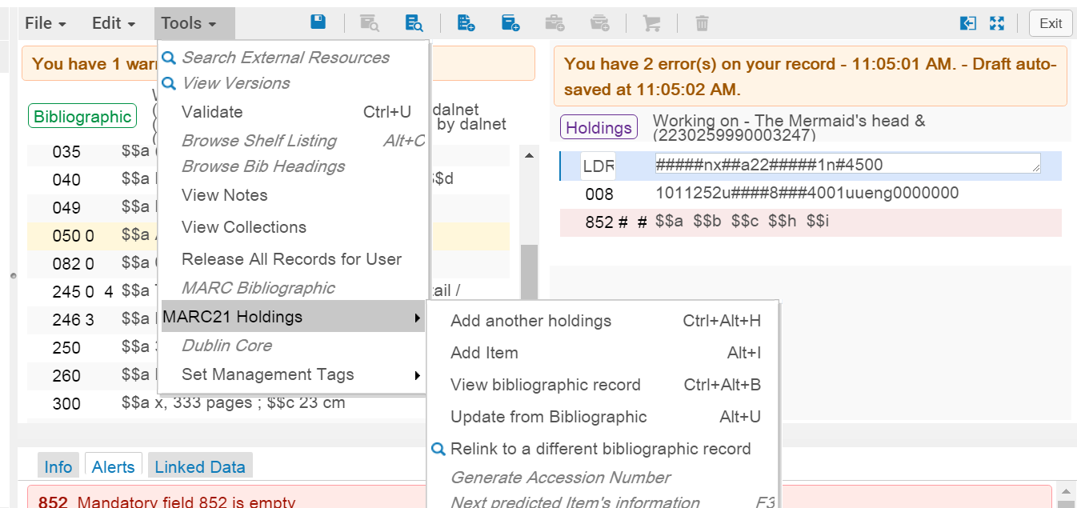
Classification Information is placed into field 852, subfields h and i:
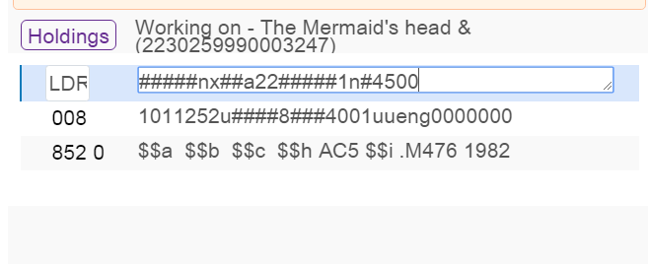
Please note: You will still need to fill in the Sublocation or collection ($$b) and
the Shelving location ($$c)
With the cursor in the 852 field, click Control F which will open the display for easier editing:
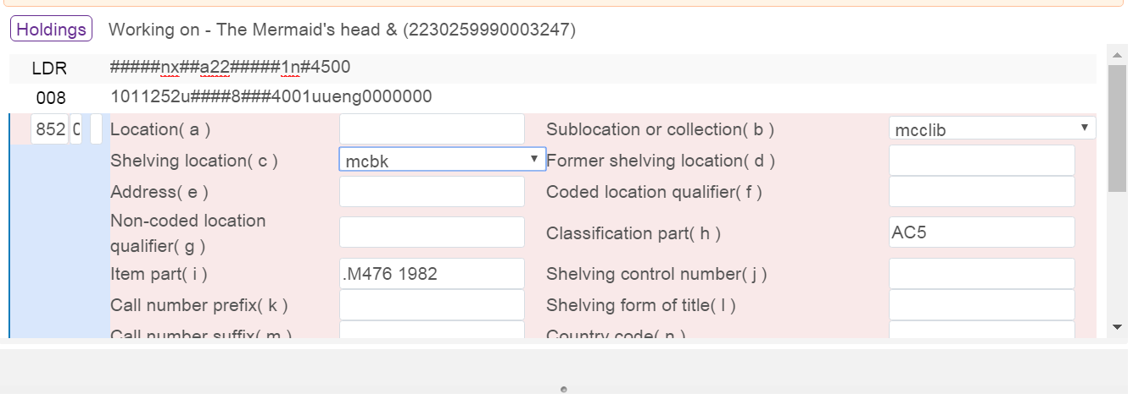

Save and Release Holdings Record:
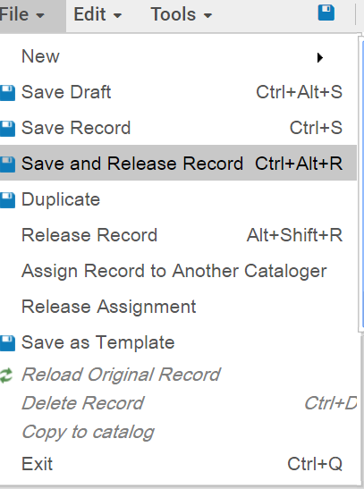
For further information, please see the following from the Ex Libris Knowledge Center
Call Number Mapping to Holdings Record: https://www.youtube.com/watch?v=Sll11qLnME8&feature=youtu.be

See additional document: How to Configure Call Number Mapping to configure which field(s) will be used as the call number in the holdings record.

