**Suppressing or Unsuppressing Bibs and Holdings in Alma**

Alma employs record suppression (or hiding a record from the public view in Primo) making it essentially viewable by “staff only” in Alma.

**Suppressing or Unsuppressing a Bib Record**

A bib record can be suppressed in Alma, which will all suppress all holdings and items attached to the bib record.

1. Suppressed records will have an eye with a red line through it, as seen below.



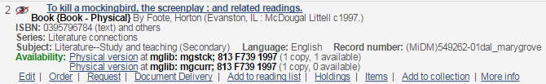2. To un-suppress the bib record in Alma, click **Edit**. The Metadata Editor will open.

3. In the Metadata Editor, click the **Tools** menu, then click **Set Management Tags**. A yellow check means this record is suppressed from public view. Click **Suppress from Discovery** to remove the check. (Likewise, Check Suppress from Discovery to hide a record in Primo.)

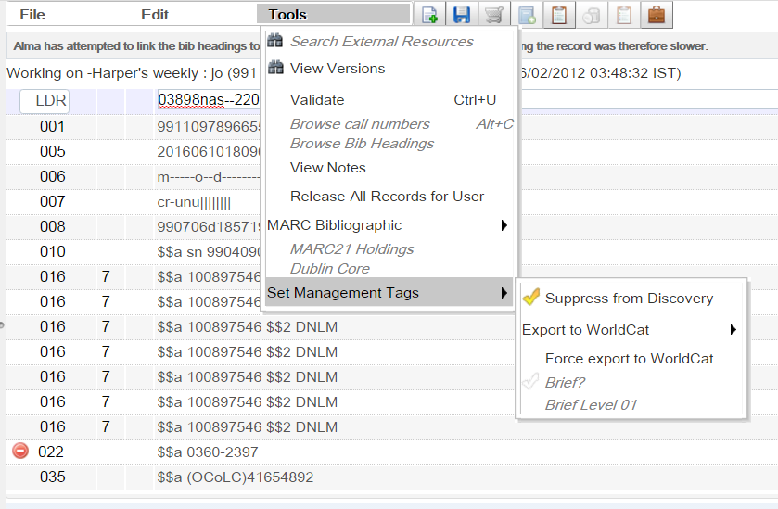

4. Click **Save**.

**Suppressing or Unsuppressing a Holdings Record**

Individual item records cannot be marked suppressed in Alma*, only the holdings record that an item is attached to can be suppressed.

5. To suppress or unsuppress holdings, click **Holdings**. The List of Holdings window will open.

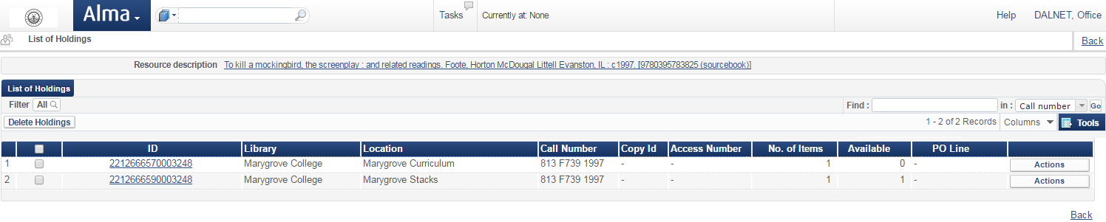6. Click the **Actions** button for the holdings record for the item that should be suppressed.

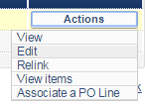  
7. Then click **Edit**. The Metadata Editor will open the Holdings Record.

8. As with the bib record, click the **Tools** menu, then click **Set Management Tags**. Click **Suppress from Discovery** to add the yellow check and thus suppress the holding record for this item. Then click **Save**.

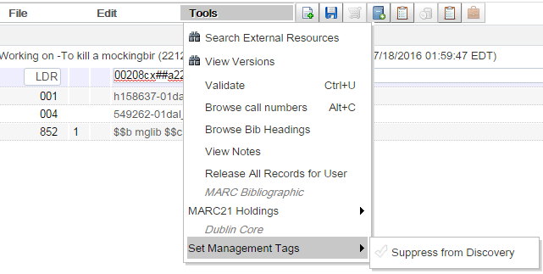

*If more 2 or more items are attached to a single holdings record and only 1 needs to be suppressed, you will need to make a separate holdings record and move that item over to it. Then that holdings record can be marked suppressed.