Alma Physical Item Cataloging DRAFT

After you have added a bib record to Alma . . .
Sample title: Spitz and Fisher's medicolegal investigation of death

Search for your title in Alma:

You can just type the title/ISBN/etc. into the search box at the top, or you may choose a dropdown area to search to be more specific (as shown above), such as Physical Items.

After the search you will get a list of hits:

To just view the MARC for the title you can click on the title. To edit the MARC you can then click on the Edit button:

You can also go straight to editing the MARC, holdings, or items, by clicking on the links below the title in your search:

The above link labeled Edit takes you straight to the MARC in the Metadata editor:

Many buttons and views in Alma are similar to the Horizon Bib and Item views.
Horizon MARC Editor
Alma Metadata Manager
You may edit the MARC record and save your work with the save icon, or with File > Save Record or, or with CTRL+S. Also make sure to File > Release Record when you are done, so that others may edit the record later if needed. Otherwise the record will remain locked for use by your user account.
Functional Cataloging Buttons in Horizon and Alma
Horizon | Function | Alma
 | View Copies/Items
 | View Inventory (Holdings/Items/Electronic Portfolios, etc.) | Or CTRL+I
 | Add Holdings | Or CTRL+ALT+H
 | Add Item | Or  Or ALT+I
 | Edit Item
 | Split Screen (to see MARC and Holdings at the same time) | 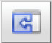
 | Save
 | Adjusts Fields Displayed in Item List

You can expand a MARC view for the LDR (Leader Fields) or the MARC Holdings fields to see a more manageable form instead of the code view.
MARC Bib LDR code view:
MARC Bib LDR expanded view:
MARC Holdings 852 code view:
MARC Holdings 852 expanded view:

To expand a view to the Form view hit CTRL+F in the filed you want to expand. Alternatively, you can use the dropdown menu, Edit > Open Form Editor.
You may toggle back and forth between viewing the MARC BIB and MARC Holdings by clicking on them on the left-hand navigation:

To view Inventory (Holdings/Items/Electronic Portfolios, etc.), click on the icon or hit the CTRL+ I buttons:

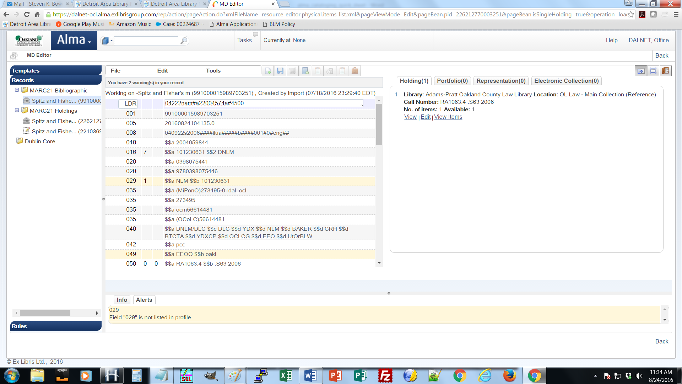

You may click on the Edit link to edit the existing holdings or the View Items link to get to the items.

Don’t forget: You can expand the 852 holdings information to the Form view with CTRL+F.
To add holdings you may click on the Add Holdings icon or hit the CTRL+ALT+H buttons.
Click the Save icon after editing or creating holdings.

If you click on the View Items link in the Holdings view this will take you to a list of items, as you would in Horizon.

Horizon View Items List:

Alma View Items List:
Click on the Add Item button to add an item.
Click on the Actions button to edit or duplicate an existing item:
To add an item with the Add Item icon you must be on the MARC Holdings screen.
Adding or editing an Item:
Notes on Item Fields
Material Type: The dropdown selection comes from the Alma section and is based of settings from migration and denote format.
Item Policy: These codes are reflective or migrated items types from Horizon and are only used to signify things that have a differing circulation policy (an exception) based on the Item Policy.
Description: This field must have differentiating information in it to indicate that this item is different than other items, i.e. so that this item can be requested at the item level instead of at the bib level. This field should therefore be used to indicate varying volumes, discs, etc. in a set.
Location Information: The Permanent Library and Permanent Location information listed on the item record are not editable in the item record as they come from the Holdings record.
Call Number: The call number is not found on the item record as it is on the Holdings record.

To Suppress or Show a MARC record in discovery (like Horizon Staff Only) click on the menu Tools > Set Management Tags and check or uncheck the Suppress from Discovery check mark for the Bib:
Note: Adding or deleing an item or changing the Suppress from Discovery check mark will automatically trigger the system to show or hide the title in the Primo catalog.
Clicking the icon or hitting the CTRL+Q buttons will Exit you from the Metadata editor. This will also prompt you to release the records if you are done with them.
To Suppress or Show a MARC Holding in discovery (like Horizon Staff Only) click on the menu Tools > Set Management Tags and check or uncheck the Suppress from Discovery check mark for the Holding:
Note: All items attached to a Holdings record are suppressed or not suppressed based on the Holding. A single Holding record cannot have some items suppressed and other not suppressed. A single MARC record can have some items suppressed and some not suppressed by having more than one Holding record attached to the MARC record, some suppressed and some not suppressed.

Deleting Physical Bibs, Holdings, Items
Note: All items and holdings must be deleted in order to delete a bib record.

Deleting Items
To withdraw (delete) an item check the box next to the item/s to withdraw in the item list and click on the Withdraw Items button:

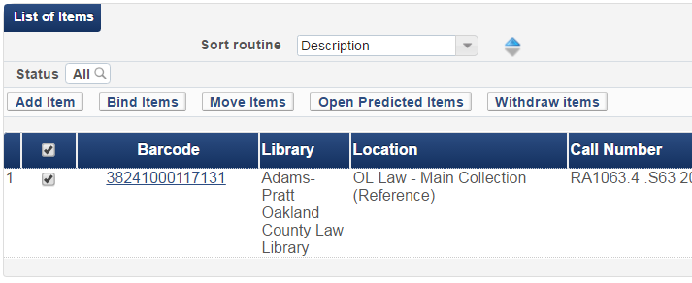
You may also click on the action button in the item list, next to an individual item, and select withdraw:
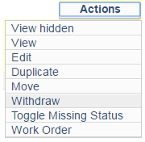
Note: The operator must have the Physical Inventory Operator Extended role in order to withdraw items.

Deleting Holdings
After all items attached to a Holdings record are deleted, Alma will prompt the operator with the following:

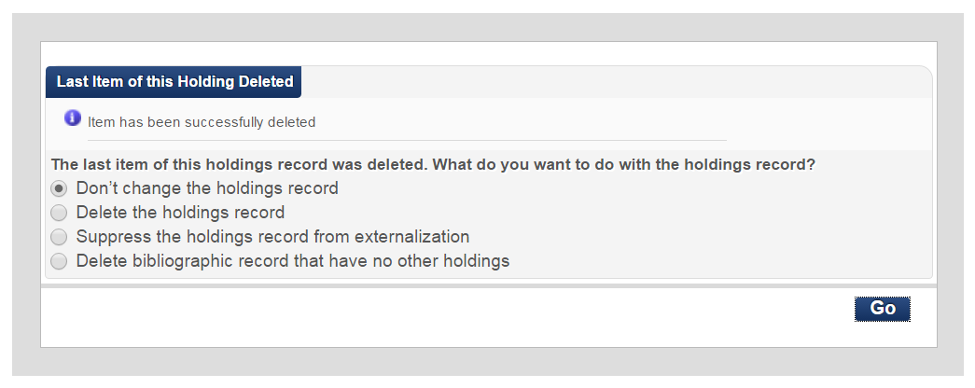
The operator may select the desired action from the list.

To later delete a holding that has no items attached, click on File > Delete Record, or CTRL+D:

Deleting a MARC Bib Record
Once all items and holdings have been removed from a MARC Bib record, the MARC record may also be deleted.
To delete a MARC record that has no items or holdings attached, click on File > Delete Record, or CTRL+D:
The operator will be prompted to confirm the deletion:
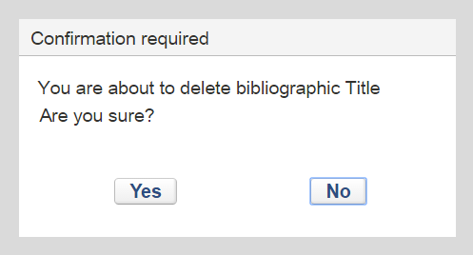

Note: Adding or deleing item and/or holdings or changing the Suppress from Discovery status of a record will automatically trigger the system to show or hide the title in the Primo catalog.

Clicking the icon or hitting the CTRL+Q buttons will Exit you from the Metadata editor. This will also prompt you to release the records if you are done with them.

