Setting Due Dates for Before or After a Closure/Break

Adding the Break to the Calendar
1. Open up your calendar. Click the Configuration Gear > Fulfillment > Library Management > Opening Hours.
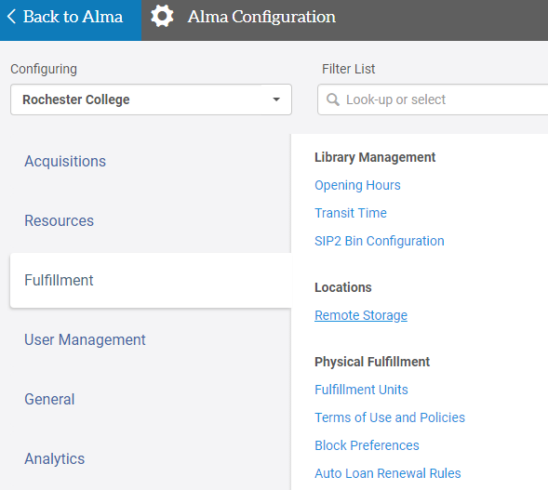
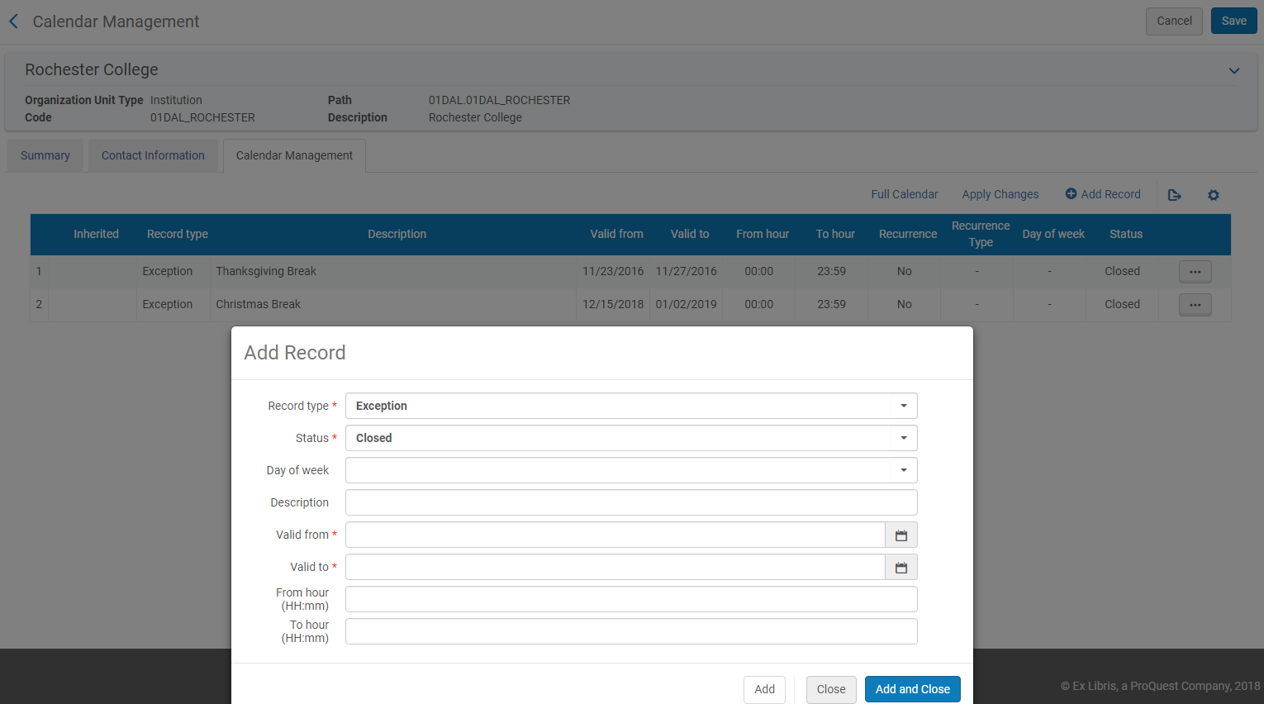
2. Click Add Record and switch the Record Type to Exception. Switch the Status to Closed. Then fill in the date(s) of your closure. Click Add and Close. Click Apply Changes and then Save.
5

4
1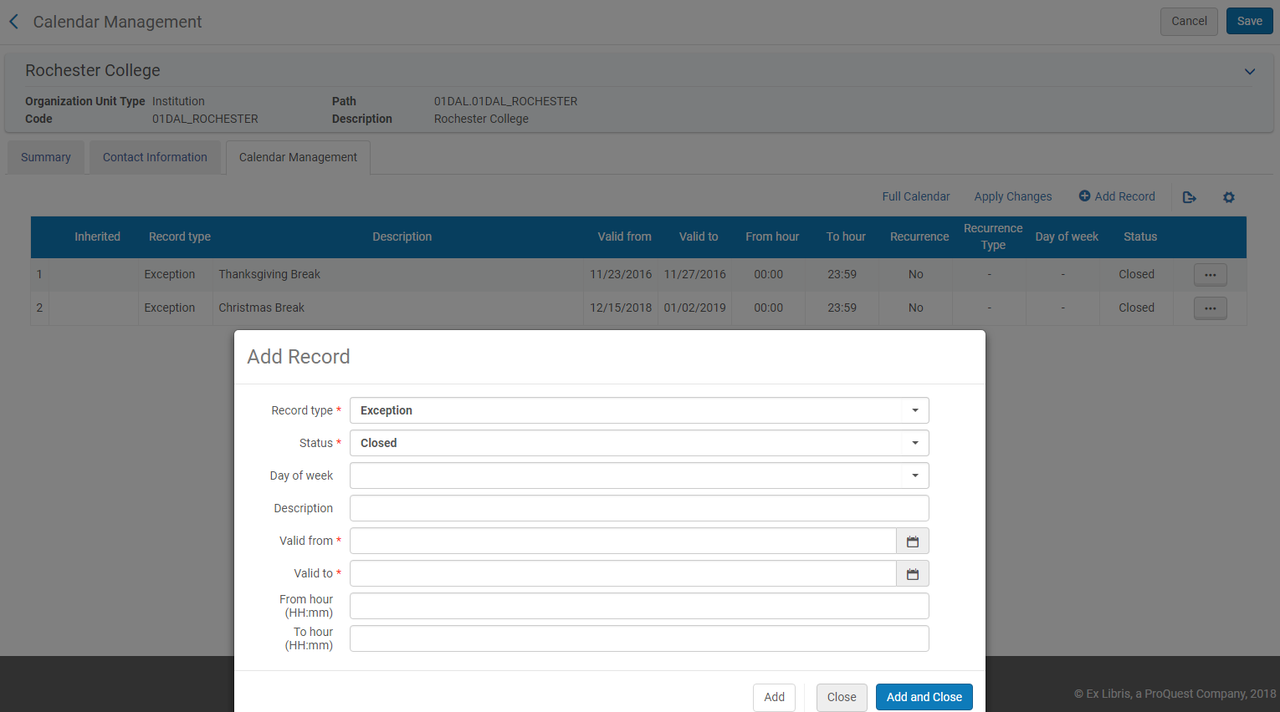

2

3
Terms of Use
3. Go to Configuration > Fulfillment > Physical Fulfillment > Terms of Use and Policies.

4. Switch the Terms of Use Type at the top of the table to Loan.
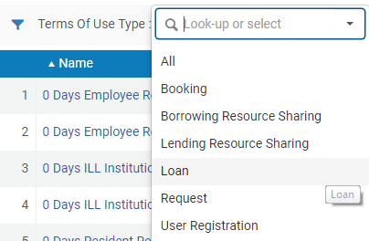
5. Select (one at a time) the one that you want to be due after break and click the ... button, then click Edit.
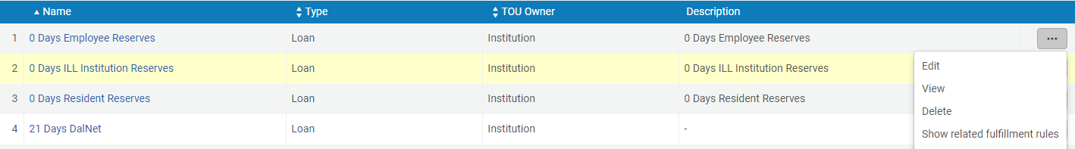

6. Scroll down to Closed Library Due Date Management and choose one of the following options from the drop-down.
- You want to make sure the one that says "Move due date to next open time" is selected if you want to move the due date forward to the next open day after the break.
- Choose the one that says “Move due time to upcoming closing time” if you want to shorten the due date to the last open day before the break.
7. Then click Next.
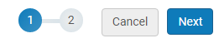
8. Then click Save.
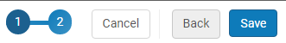

Apply Changes
9. Go back to Calendar Management (Configuration Gear > Fulfillment > Library Management > Opening Hours) and click Apply changes.
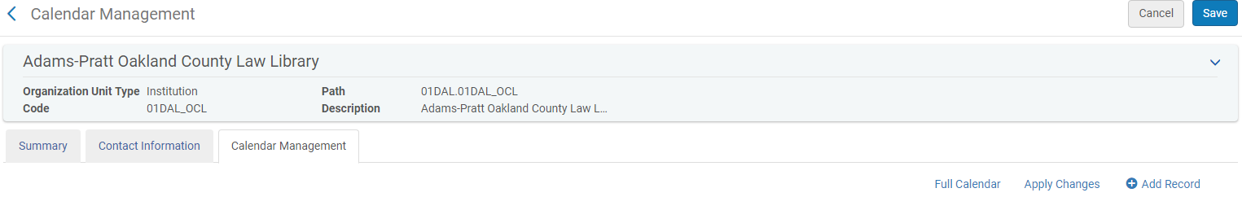

kae/10-2018

