Binding Print Serials in Alma - Including Work Order Process

Contributor(s): Giuliana Tarascio, Amanda Martimbianco
Last Updated: 9/3/2017

Background

This workflow is designed to use functionality in Alma in order to help us keep track of print serials issues that we are binding. Key benefits of using Alma for binding are:
- LR&A Staff keep track of print serials going off to binding in Alma - instead of using spreadsheets
- The binding work order enables us to print a ‘slip’ with information for the binding vendor to know what to do with print serials we send them - instead of using spreadsheets
- The binding work order merges print serial items into a single volume with a barcode - more accurately reflecting our holdings - and able to recalled through Alma into the LR&A Unit when required (eg for maintenance). Also provides opportunity for serials in eligible collections such as general to be loaned by students and staff.
- Using a binding workorder in Alma enables RMIT staff and students to know in LibrarySearch when print serials are unavailable because they are undergoing binding

NOTE: Include supplements in the bound volumes - but don’t add any information about them in the Alma bound volume item record or as information to be printed on the bound volume spine label (as the descriptions will become too long and confusing).

Bookmarks to Major Workflow Steps

Rubber banding together titles

Input Binding Instructions into POL

Change the Issues to Bound in Alma

Scan the Items in to the Department and Set the Status of the Work Order to Binding

When Items Return, Add Barcode

Change Work Order Status

Workflow

Rubber banding together titles
- Collect issues to be bound together.
- Place in issue order with the oldest title on the top, more recent on the bottom
(eg. 1,2,3,4 - NOT 4, 3,2,1)
- Rubber band titles together

Input Binding Instructions into POL
Before commencing you must ensure that you have added binding instructions for the particular serial to the POL Receiving Notes. The notes should be (replace [ ] areas as per instructions below):

* PERMANENT INSTRUCTIONS FOR BINDER: [writing colour], [shade of cover material as per Robel’s numerical shade listing here: Print Serials Binding - Robels Binding Information 2016], [pattern: number of issues/date range of issues to bind together at a time (if this is uniform)] *

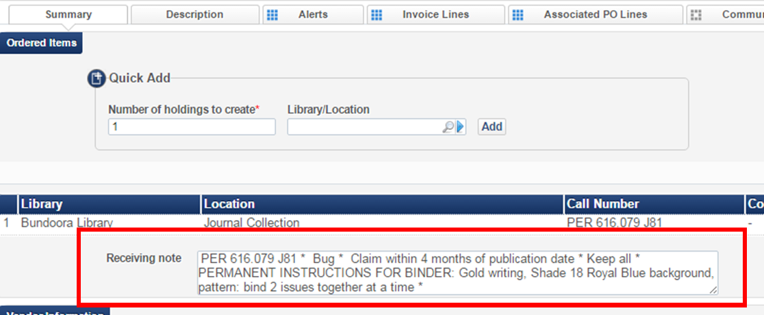

Example 1:
* PERMANENT INSTRUCTIONS FOR BINDER: Gold writing, shade 34 Forest Green background, binding pattern: 1 volume is 4 issues. Spine title: LITERATURE BASE, [VOLUME NUMBER], [YEAR], PER 028.505 L776.b *

Example 2:
* PERMANENT INSTRUCTIONS FOR BINDER: Gold writing, shade 11 Black background, binding pattern: 1 volume is 4 issues. Spine title: MIDIRS MIDWIFERY DIGEST, [VOLUME NUMBER], [YEAR], PER 610.73678028 M111.m *

Change the Issues to Bound in Alma

- Do an All titles repository search (by title or ISSN) for the journal that needs to be bound.

- Click the Holdings link to view the list of Holdings (Library/Location) for the journal.
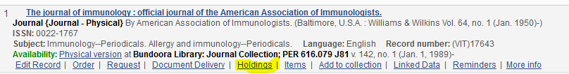

- Click Actions, then View Items.

- Select the checkbox next to the issues you want to bind.

NOTE: If the issues you want to bind are not in Alma, create 2 temporary dummy issues that you can then bind together in the next step. The quickest way to do this is by clicking on ‘duplicate’ from another issue for that serial:

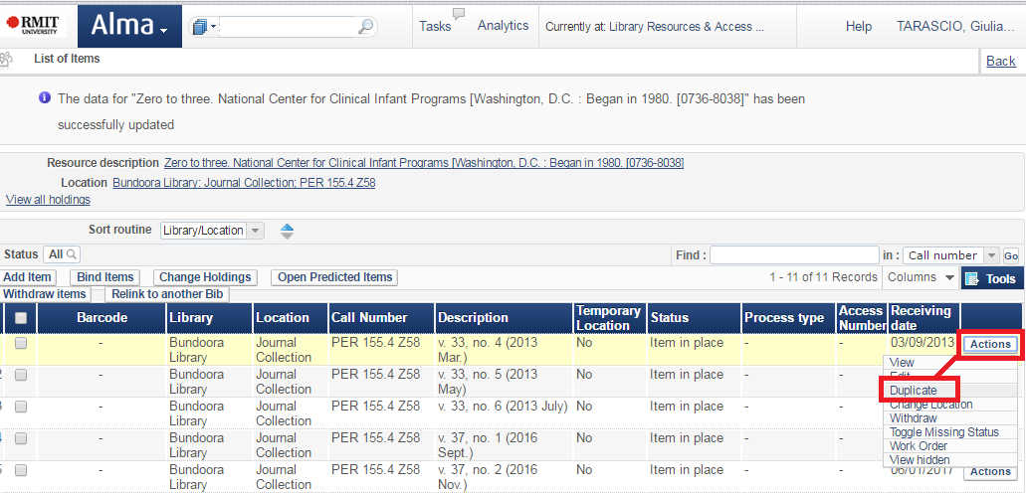

- Click on the Bind Items button.

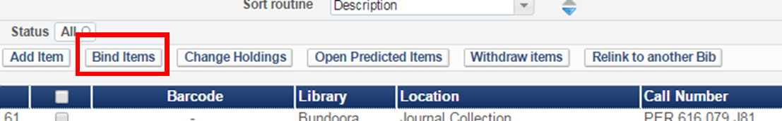

- The Selected items to bind into one volume page opens confirming your selection.

- Click Next.

- Work order type: Library Technical Services

- Note: [enter date sent and spine label instructions, e.g.
“To Bind: 16/3/2017.
Note to binder to print on spine: LITERATURE BASE, 25, 2014, PER 028.505 L776.b”

- Work order department: Unit

- Create and Edit

- A pop up with the note “Binding the selected items will withdraw them from the system. Are you sure you want to continue?” will appear. Click Confirm

- Enter / update Enumeration, Chronology as needed. [Use the Authorised Print Serial Bound Volume Item Descriptions tab in the Print Serials Standard Naming Format for Holdings & Items guide for formatting]

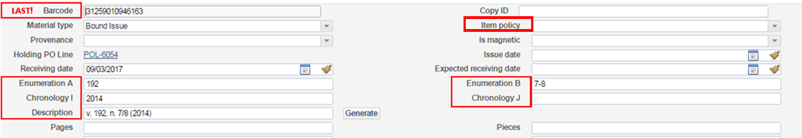

- Complete the Description field. [Use the Authorised Print Serial Bound Volume Item Descriptions tab in the Print Serials Standard Naming Format for Holdings & Items guide for formatting]

- Change the Item Policy field to one of the following, based on the item collection:

Item policy to use:
Location | Item Policy
Journal Collection | Not for Loan
General Collection | Standard Loan

- Scan in the barcode last.

- Give the barcode label to Amanda Martimbianco to store until the bound item returns from the binders

- Save (if you scan in the barcode it will save automatically)

Scan the Items in to the Department and Set the Status of the Work Order to Binding

- Navigate from Alma menu to: Acquisitions => Post-Receiving Processing => Scan In Items
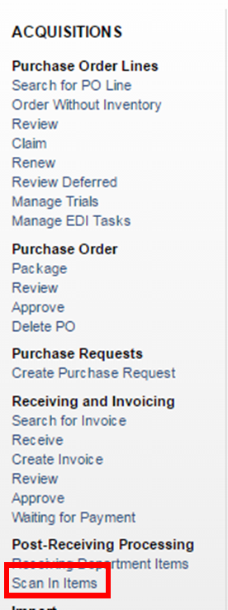
- Fill in as follows:
Set Status To: x Binding
Automatically print slip: No
Done: No

- Scan item barcode - if entering barcode manually select OK button

- Navigate from Alma menu to: Fulfillment => Resource Requests => Manage in Process Items
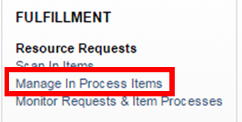
- Find the Title you just set to x Binding Status

- Click Actions then Update Expiry

- Change Expiration Date to approximately 1 month in the future (reflecting when we expect the binding to return from binders)

- Save

- For same title you’re binding, click Actions then Print Slip

- Go to the library email account cataloguing.library@rmit.edu.au. From here go to binding slips label in the left hand menu. There you can retrieve binding slip generated email.

- Print this email and attach to print serial issues you are binding on this work order (so the external binders know what to do with it)

_________________________________________________________________________
To see all items with the status of x Binding:

- Navigate from Alma menu to: Fulfillment => Resource Requests => Manage in Process Items

- Filter by Process Status selecting x Binding
_________________________________________________________________________

When Items Return, Add Barcode

- Navigate from Alma menu to: Fulfillment => Resource Requests => Manage In Process Items
- Filter to x Binding.

- Locate item returned from bindery.

- Actions => Edit Inventory item

- Double check that the Enumeration, Chronology, and Description in the item record correspond to the volume you have in hand.

- Double check the Permanent library and Permanent location.
- Save

- Retrieve correct barcode from Amanda Martimbianco and put on the item [according to Serials processing - Adding a barcode procedure]

Change Work Order Status
- If not already there Navigate from Alma menu to: Fulfillment => Resource Requests => Manage In Process Items and Filter to x Binding.

- Place a checkmark in the box to the left of the item and select Physical Processing from drop down menu, and then Change Status
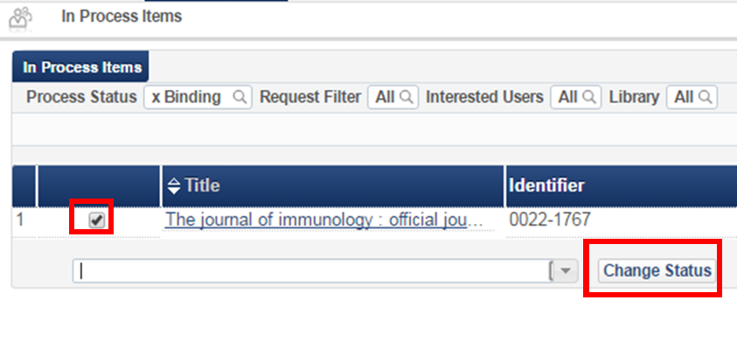
OR
- Select Items - in department from Alma Tasks dashboard widget
- Place a checkmark in the box to the left of the item and select Physical Processing from drop down menu, and then Change Status
OR
- After setting the barcode for each volume, batch-update them:
  - Fulfillment => Resource Requests => Scan in Items
  - Set Status To: Physical Processing
  - Done: No
  - Scan/manually enter item barcode and OK: [this will set status to Physical Processing for that item]

- Place item onto the Items Needing End Processing shelf for RFID tag and barcode tape/cover.

