Managing COUNTER-Compliant Usage Data
Alma New UI
DALNET Version
7/9/18
Table of Contents

Configuring Counter Subscribers 1 - 2

Managing SUSHI Accounts 3 - 7

COUNTER Report Types 7

Manually Uploading COUNTER Data 8 - 15

Please Note: Pages 1 - 7 are based on the documentation titled Managing COUNTER-Compliant Usage Data from the Ex Libris Knowledge Center.

Manually Uploading COUNTER Data is based on documentation Jeff Zachwieja made for DALNET First Thursday, September 7, 2017:
http://www.dalnet.org/kb/alma/manually_activating_resources.pdf

Alma can collect and report on electronic resource usage statistics information supplied by content providers in COUNTER format.

Many vendors can provide COUNTER statistics for your institution’s users’ usage. In some cases, you receive this information in a file and upload the information to Alma manually. In some cases your vendor supports the SUSHI protocol which allows Alma to automatically retrieve (harvest) and upload the data automatically.

- Configuring COUNTER Subscribers
You must have the role of Acquisitions Administrator to configure this.

Subscribers are used to maintain multiple accounts with a vendor. For an institution, subscribers can be used to separate the usage data by campus or library (when the vendor can distinguish access to its resources by the IP addresses of each entity).

Alma requires you to define at least one subscriber.

Select: Acquisitions > General > Subscribers:
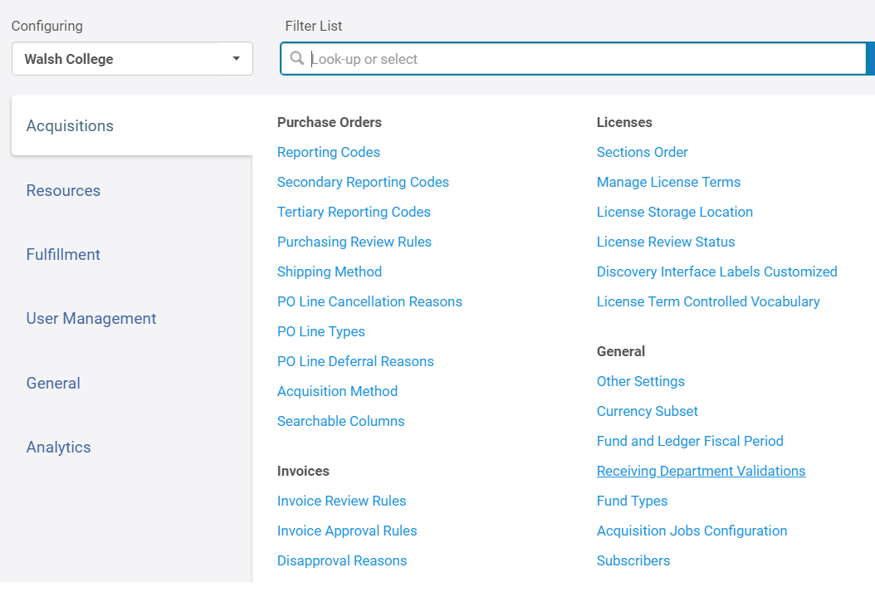

Click on Add Row:
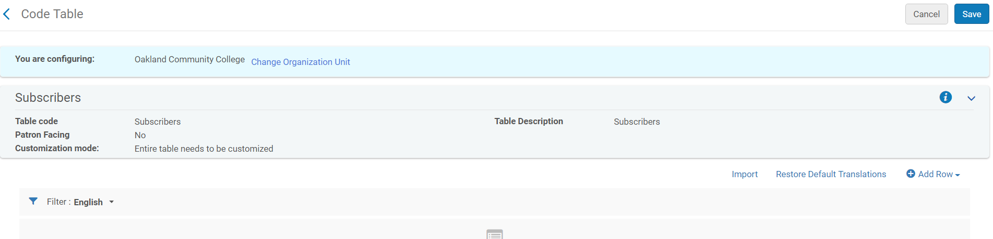
Fill in Table and Click on Add Row Button:
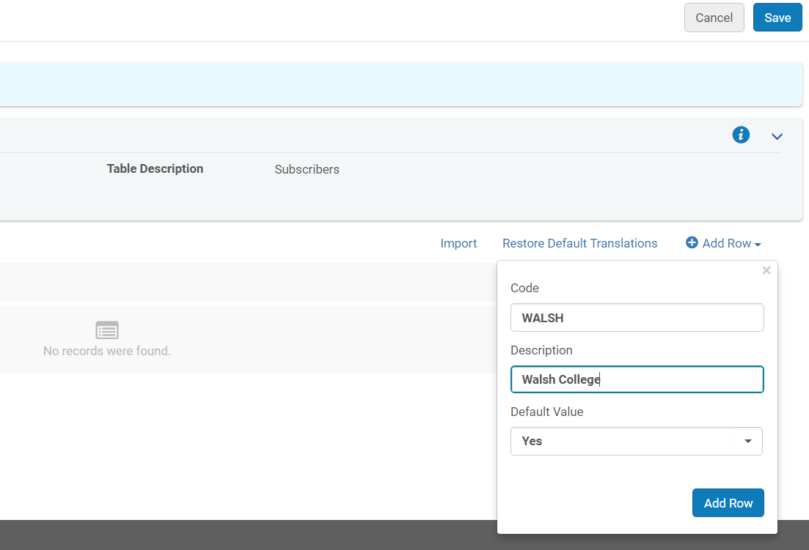

Screen confirms that Subscriber is enabled. Click Save:
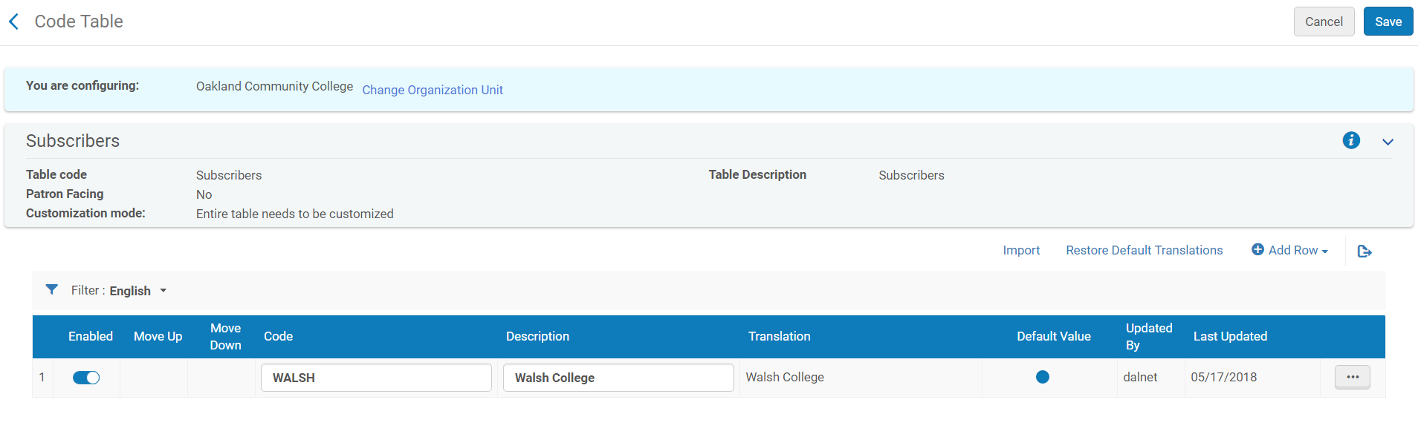

- Managing SUSHI Accounts
You must have the role of Vendor Manager to configure this.

SUSHI accounts enable Alma to automatically retrieve COUNTER reports from vendors. You create a SUSHI account for each vendor and for each report type; a single vendor may require multiple SUSHI accounts, one for each report type.

COUNTER Report Types
- JR* (Journal)
- BR* (Book)
- DB* (Database)
- PR* (Platform)
- MR* (Multimedia)

For more information about COUNTER Report Types, please see the following:
https://knowledge.exlibrisgroup.com/Alma/Product_Documentation/010Alma_Online_Help_(English)/020Acquisitions/090Acquisitions_Infrastructure/010Managing_Vendors/Managing_COUNTER-Compliant_Usage_Data#COUNTER_Report_Types

To add a SUSHI account

- Make sure that you have a subscriber defined for your institution (see page 1)
- For vendors that are actually subscription agents for other vendors (access providers or publications) each report type from each access provider or publication requires an additional SUSHI account for each access provider or publication; multiple reports from the same vendor require multiple SUSHI accounts. See page 6 for supported COUNTER Report types from the Ex Libris Knowledge Center.

Path to configuration in Alma:
Acquisitions > Acquisitions Infrastructure > Vendors > Select vendor you wish to configure and click Ellipsis. Select Edit:

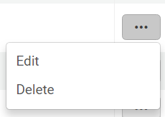

Select Usage Data tab:

Please note: If you have not yet added a Vendor and a Vendor Account, please see page 12.
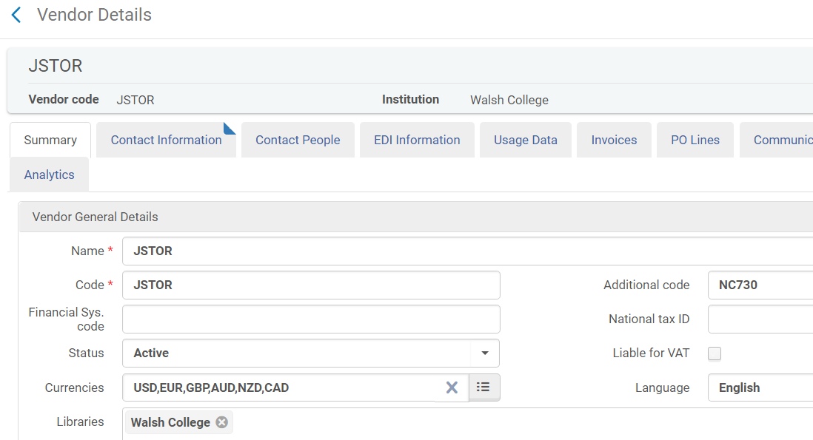

Under SUSHI Accounts Click on Add:
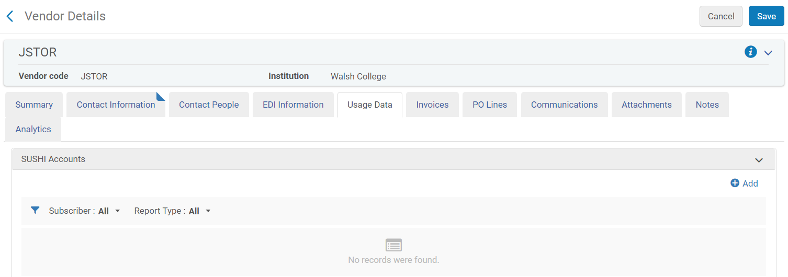

In SUSHI Account box, begin typing and after three letters are entered a drop-down list of SUSHI-certified vendors appears (this is predefined by Ex Libris).
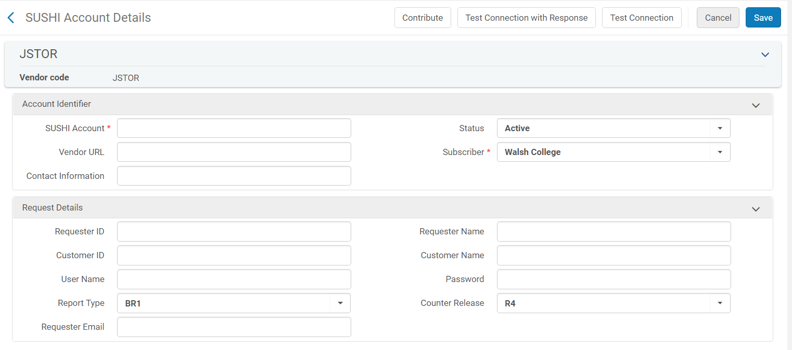
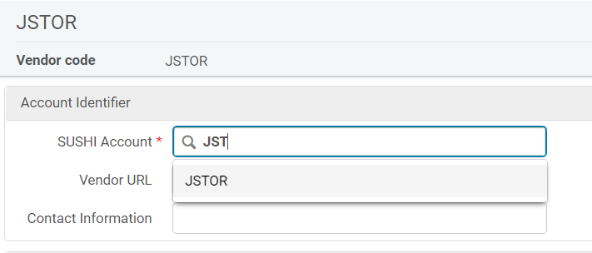
If you select any of the vendors from this list, the Vendor URL is pre-filled with the correct URL for the vendor (other information will also be prefilled as well).

The COUNTER Release used by Ex Libris is R4 which will be pre-populated for you.

Please note the following:
Support for COUNTER 5 and SUSHI lite is on the Alma Roadmap. Ex Libris is closely following developments in the industry regarding these protocols and will incorporate them into Alma in a timely manner, as the industry develops. We are aware that COUNTER has stated that “In January 2019, all publishers and vendors are required to comply with the new Release of the Code of Practice” and Ex Libris product management is therefore closely following all developments.

Fill in areas in red and anything else relevant to your vendor account:
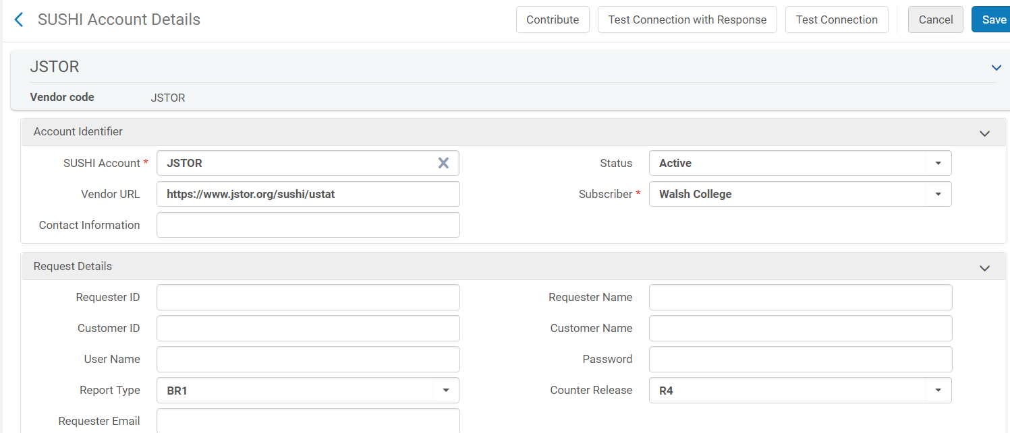

Click Add:

Note: you do not need to select a predefined certified vendor; you may enter any value you like as long as you have the information needed to continue filling in the account details.

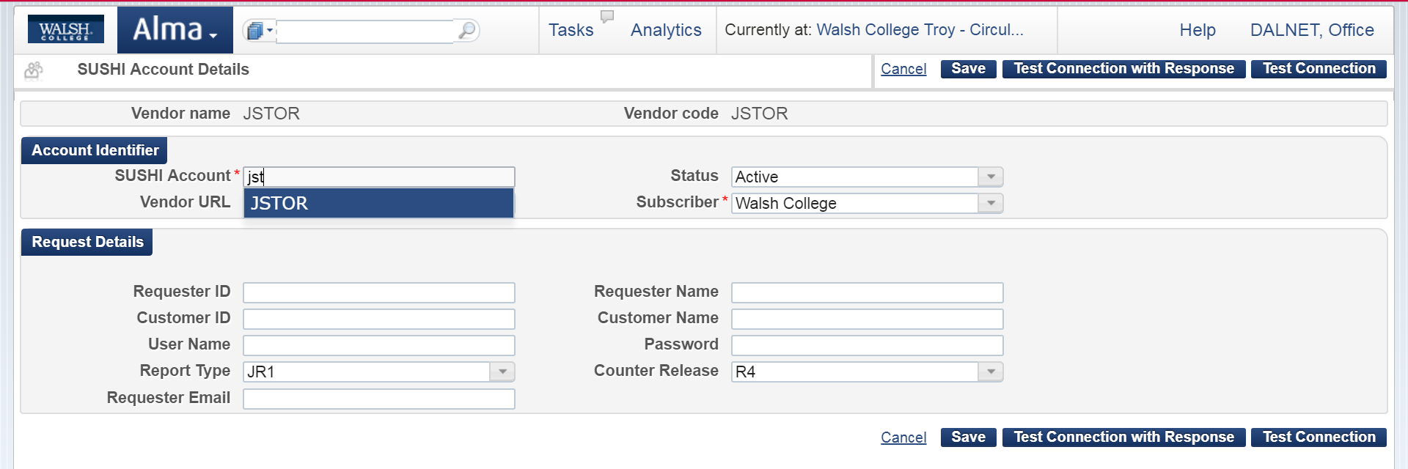

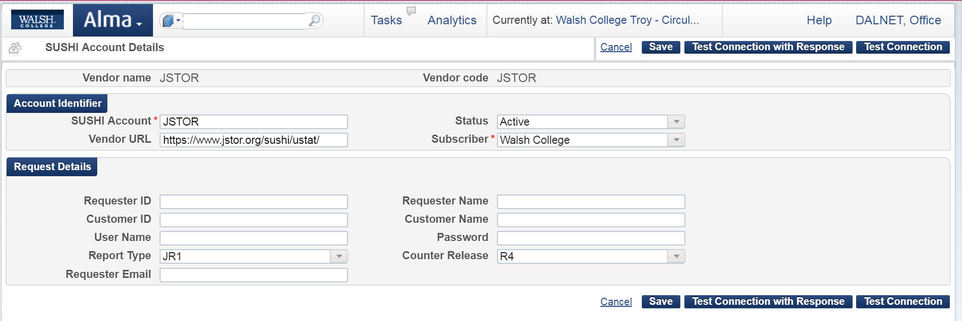

Test the connection by clicking on the Test Connection button. If there is an error, an error message appears at the top of the page. In this case, you may want to click Test Connection with Response to view a Zip file containing both the SUSHI request and response packages (in XML) sent to/from the vendor. If needed, send the file to dalnethelp@wayne.edu for assistance.

Click Save button if Test Connection succeeds.

This has important information that you will reference often:
https://knowledge.exlibrisgroup.com/Alma/Product_Documentation/Alma_Online_Help_(English)/Acquisitions/090Acquisitions_Infrastructure/010Managing_Vendors/Managing_COUNTER-Compliant_Usage_Data#COUNTER_Report_Types

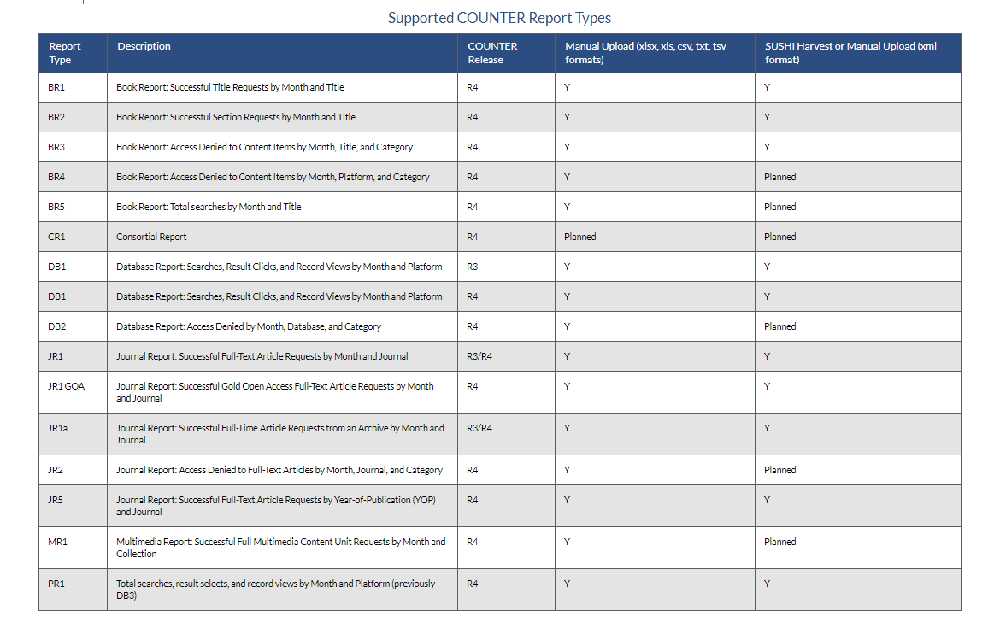
- Manually Uploading COUNTER Data

You must have the following roles to do this:
- Usage Data Operator
- Vendor Manager

Your vendor can supply you with COUNTER data for manual upload to Alma. The data must be in one of the following formats: xsls, xls, csv, txt, or tsv. For some report types, you can also manually upload data in xml format. Please see COUNTER Report Types on page 7.

Log into your vendor site to access the COUNTER Reports. If you do not know this information, please contact your vendor.
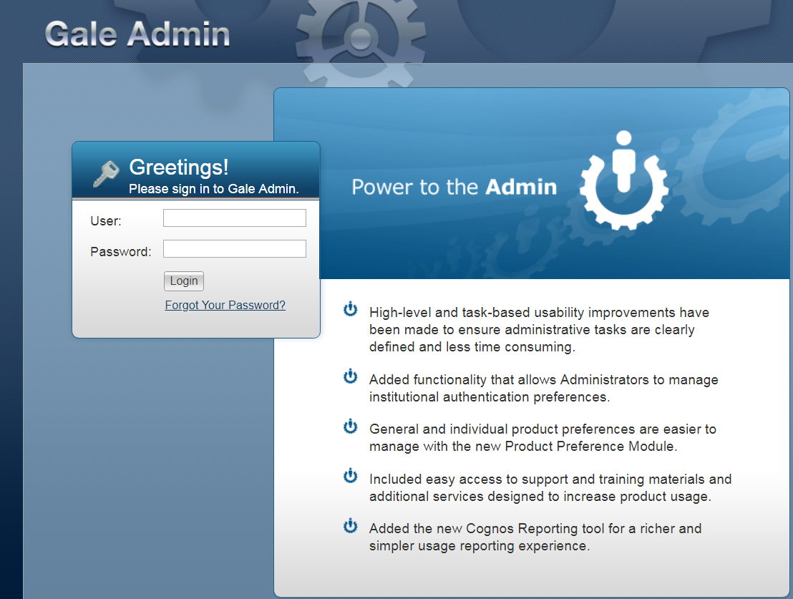

Vendor sites will vary. This example is from Gale. Click on View/Edit:
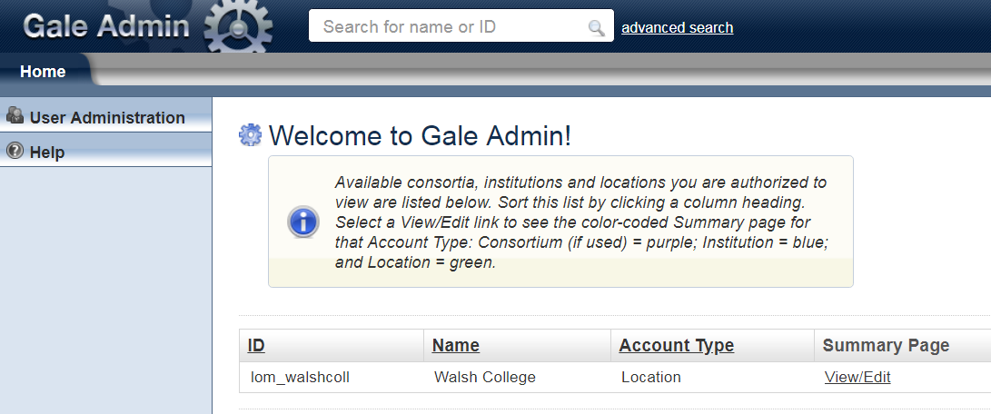

Click on Reports > View Usage Reports:

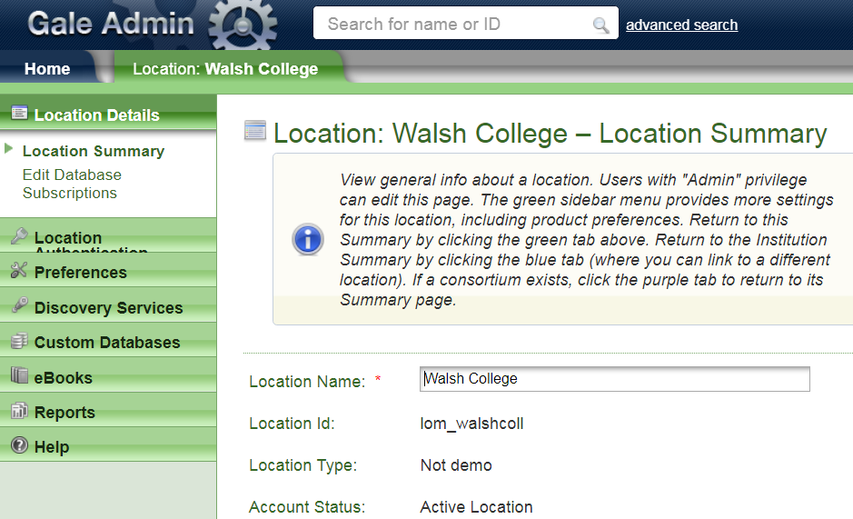
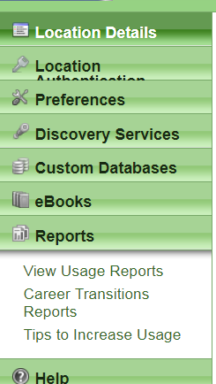

Click on the name of the report you wish to run. See table on page 7 for further information about report types. This example used Journal Report 1 (JR1) which is usage by journal title.
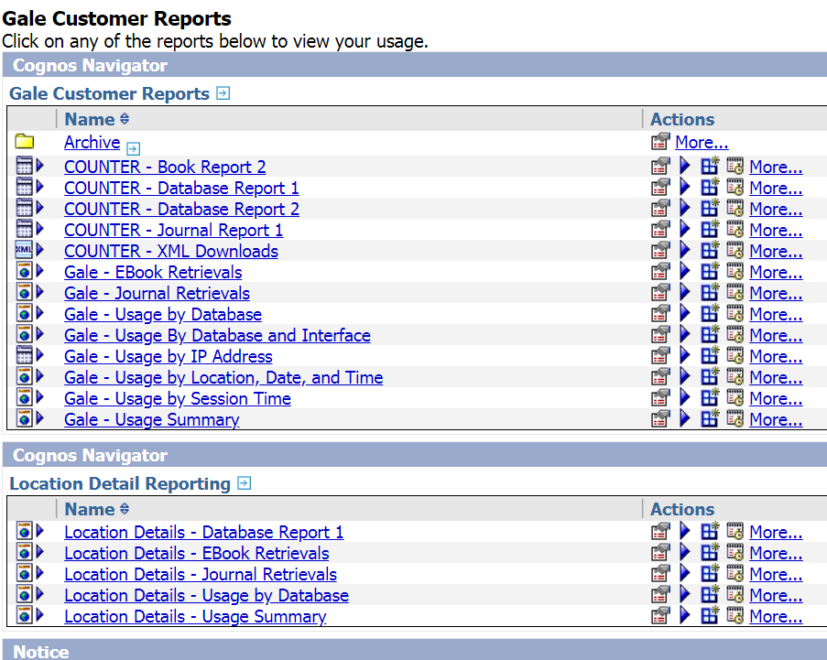

Select a date range and which database you wish to include in the report. If you wish to have them all included, Select all. Click Finish:
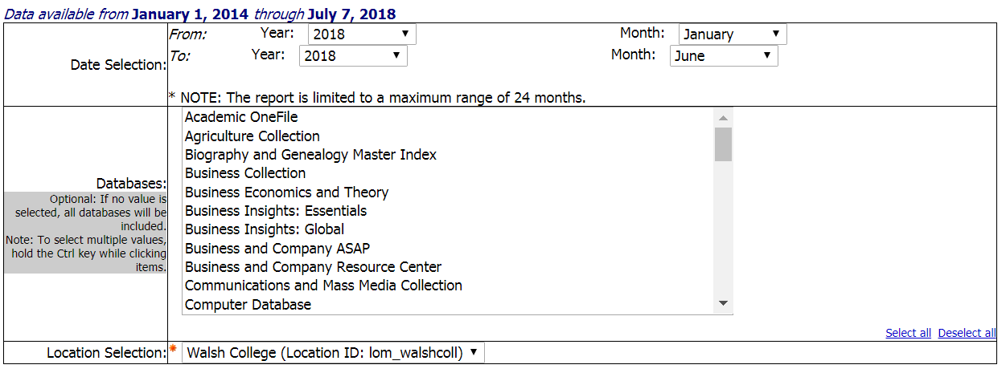
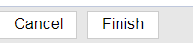

This is a large report so it took time for it to run:
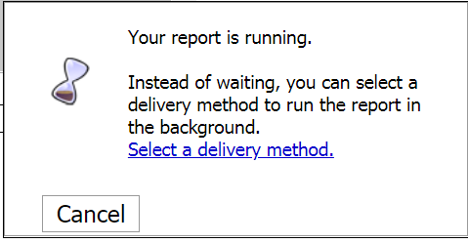
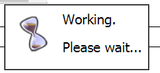
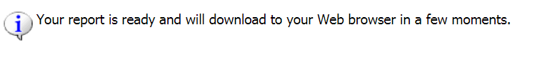

I didn’t select a delivery method. Once done, it automatically downloaded to my web browser which was Chrome. Open it and click on Enable Editing. Browsers will vary.

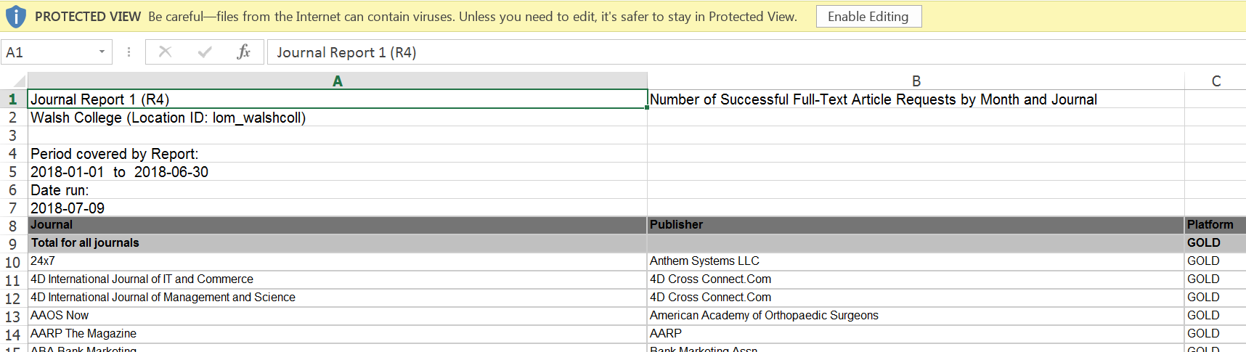

Save the file to an area on your computer that is accessible. Change the file name to something useful. The below example is saved in Excel 97-2003 format (*.xls)
The default format for download on my computer is the new Excel format (*.xslx).
Files may also be saved in CSV comma delimited format (*.csv) or Text tab delimited format (*.txt). Per Jeff’s documentation, he suggested to save Gale COUNTER reports in a format other than .xslx

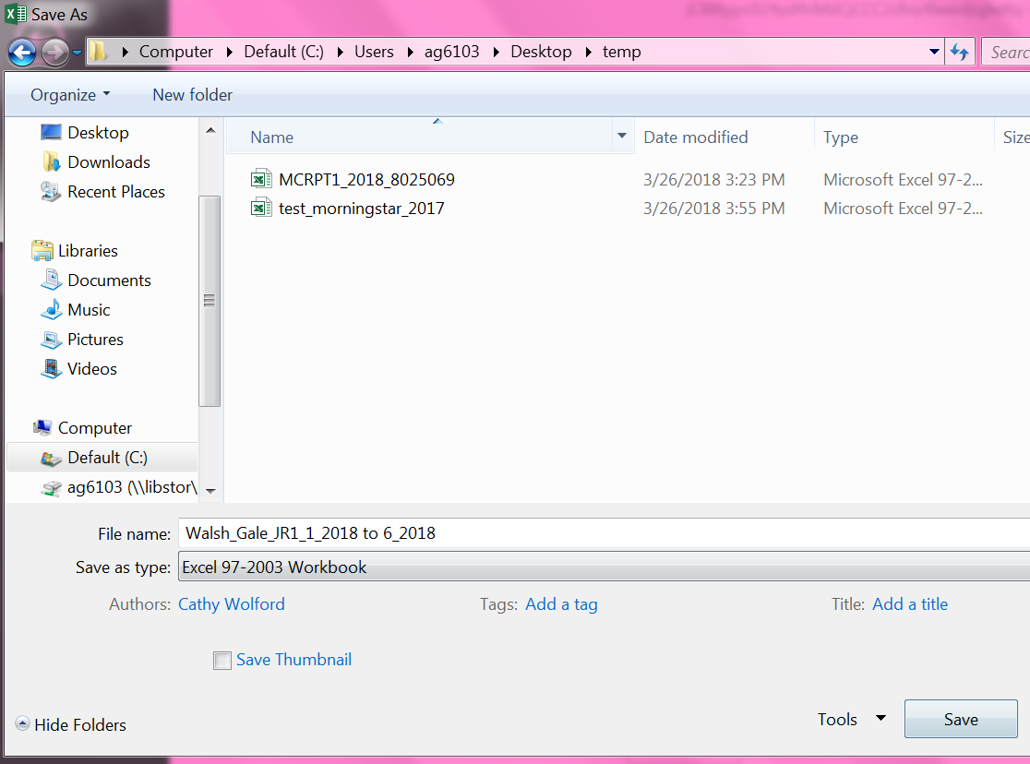

Walsh Gale JR1 Report for Jan. 1, 2018 – June 30, 2018
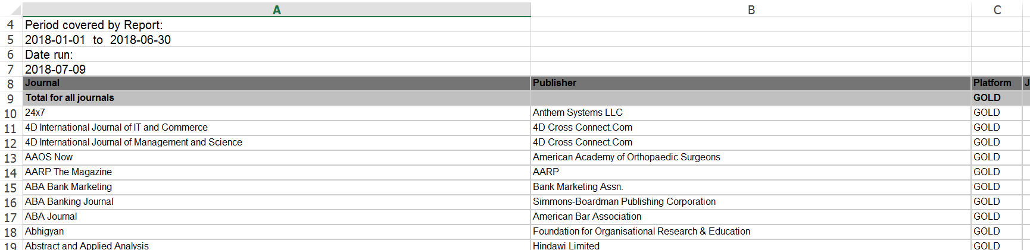

To upload the usage data in Alma:
Acquisitions > Acquisitions Infrastructure > Vendors > Choose a vendor.
Please note that this path requires the Vendor Manager Role. If you do not have that role you may upload through this path: Acquisition > Import > Load Usage Data.

Click on the ellipsis and select Edit:
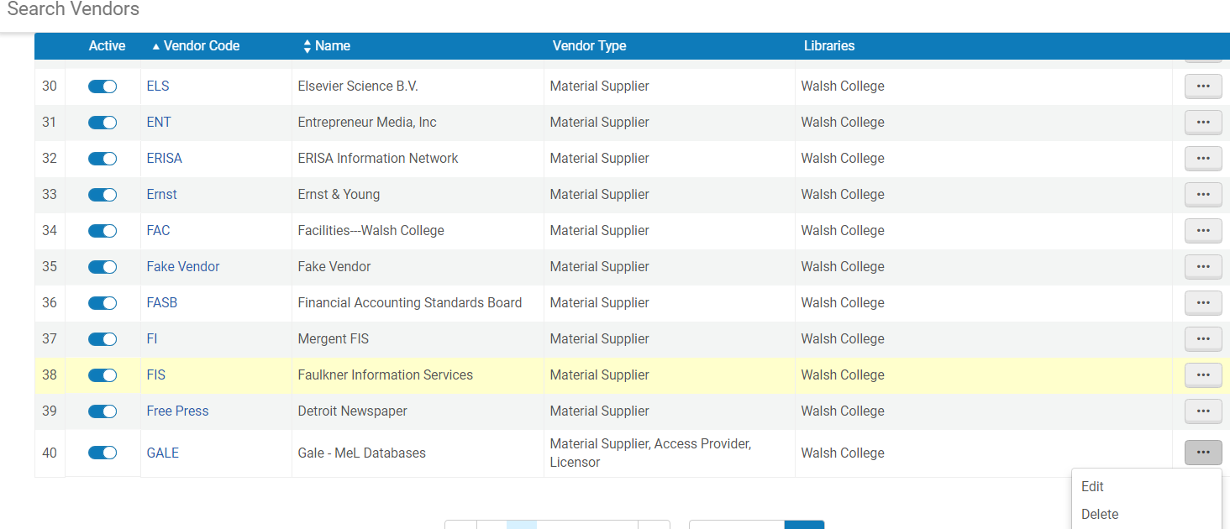

Click on Usage Data tab:
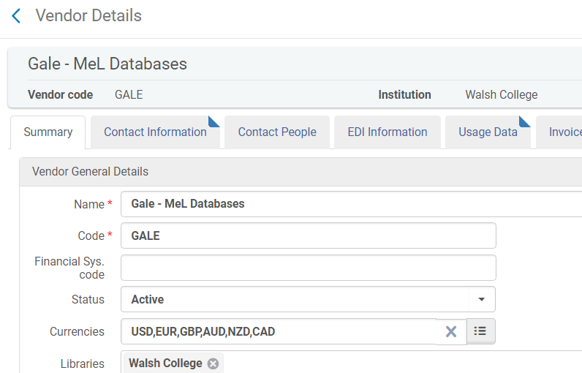

Click on Upload File:
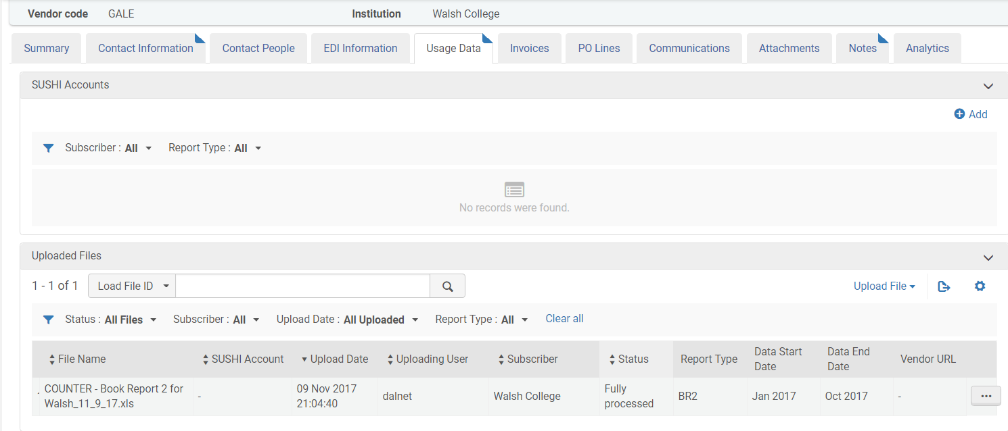
Select the file and click on Upload File.
Depending on file size this may take time. File is now uploaded.
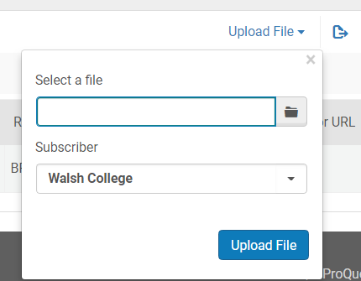
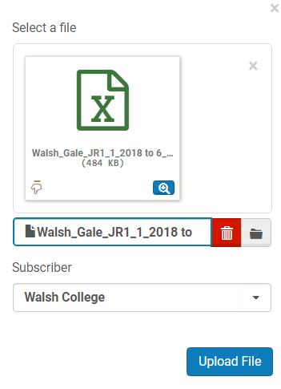

Uploaded Files. Click on the proper file clicking on the ellipsis and select view or download:
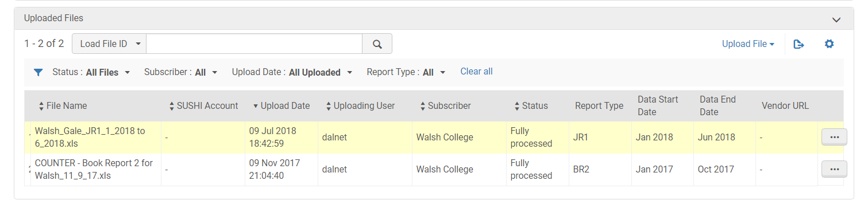

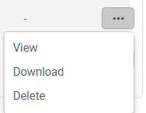
NOTE: You do not have to create a SUSHI account to retrieve COUNTER data from a vendor. Whether or not you configure a SUSHI account for a vendor, a vendor can provide you with COUNTER data to upload manually into Alma.

- To Add a Vendor and a Vendor Account please view the following:
https://knowledge.exlibrisgroup.com/Alma/Product_Documentation/Alma_Online_Help_(English)/Acquisitions/090Acquisitions_Infrastructure/010Managing_Vendors#Adding_a_Vendor_and_Vendor_Account

