Managing COUNTER-Compliant Usage Data
DALNET Version
7/20/17
Table of Contents
Configuring Counter Subscribers 1-2

Managing SUSHI Accounts 3-6

COUNTER Report Types 6

Manually Uploading COUNTER Data 7-12

Alma can collect and report on electronic resource usage statistics information supplied by content providers in COUNTER format.

Many vendors can provide COUNTER statistics for your institution’s users’ usage. In some cases, you receive this information in a file and upload the information to Alma manually. In some cases your vendor supports the SUSHI protocol which allows Alma to automatically retrieve (harvest) and upload the data automatically.

- Configuring COUNTER Subscribers
You must have the role of Acquisitions Administrator to configure this.

Subscribers are used to maintain multiple accounts with a vendor. For an institution, subscribers can be used to separate the usage data by campus or library (when the vendor can distinguish access to its resources by the IP addresses of each entity).

Alma requires you to define at least one subscriber.

Path to subscriber configuration in Alma:
Acquisitions > Acquisitions Configuration > Configuration Menu > General > Subscribers
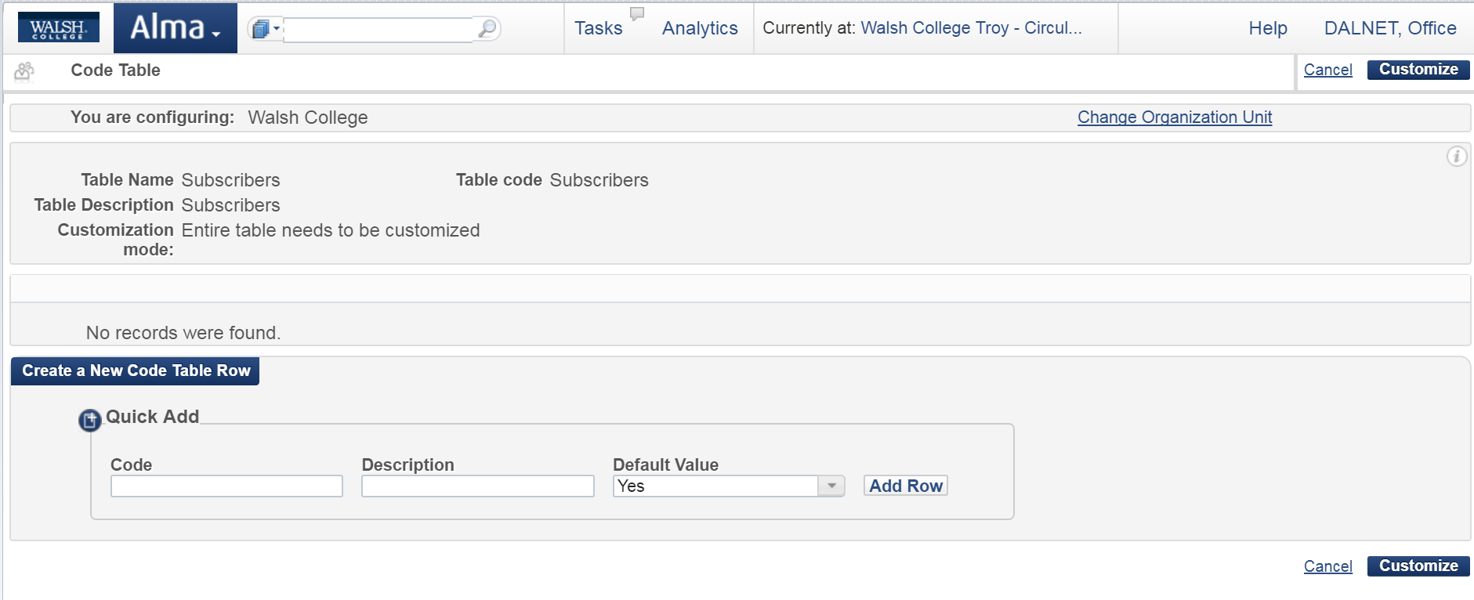
In Quick Add enter information and then click on “Add Row” button:
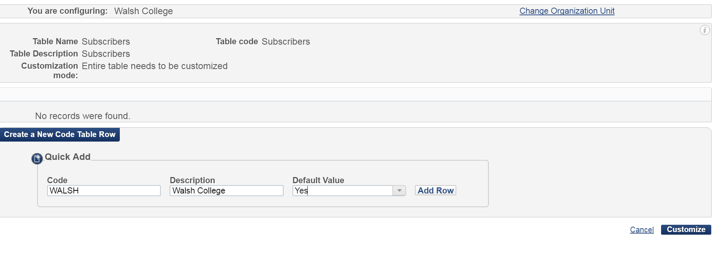

Screen confirms that subscriber is enabled. Click Save:
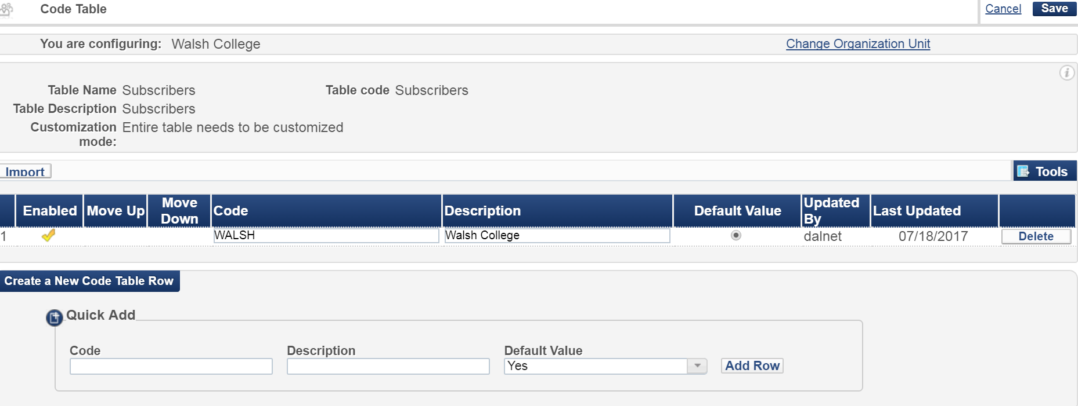

- Managing SUSHI Accounts
You must have the role of Vendor Manager to configure this.

SUSHI accounts enable Alma to automatically retrieve COUNTER reports from vendors. You create a SUSHI account for each vendor and for each report type; a single vendor may require multiple SUSHI accounts, one for each report type.

COUNTER Report Types
- JR* (Journal)
- BR* (Book)
- DB* (Database)
- PR* (Platform)
- MR* (Multimedia)

To add a SUSHI account

- Make sure that you have a subscriber defined for your institution (see page 1)
- For vendors that are actually subscription agents for other vendors (access providers or publications) each report type from each access provider or publication requires an additional SUSHI account for each access provider or publication; multiple reports from the same vendor require multiple SUSHI accounts. See page 6 for supported COUNTER Report types from the Ex Libris Knowledge Center.

Path to configuration in Alma:
Acquisitions > Acquisitions Infrastructure > Vendors > Select vendor you wish to configure then click on Actions > Edit > Select Usage Data tab:
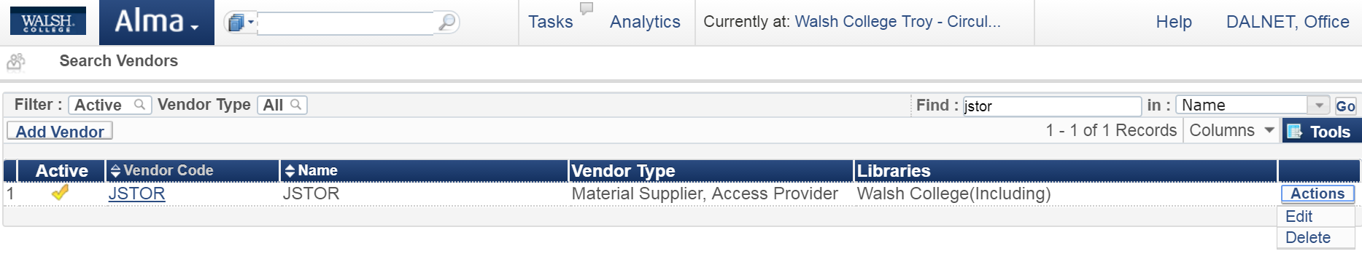

Continued on next page

Click on Usage Data Tab.
Please note: If you have not yet added a Vendor and a Vendor Account, please see page 12.
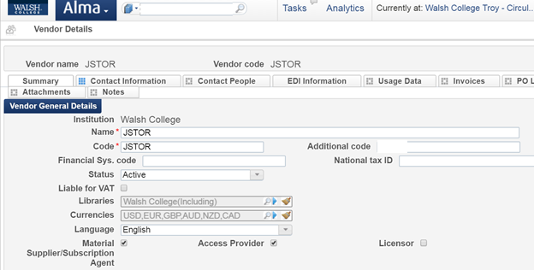

Put check in SUSHI vendor box:
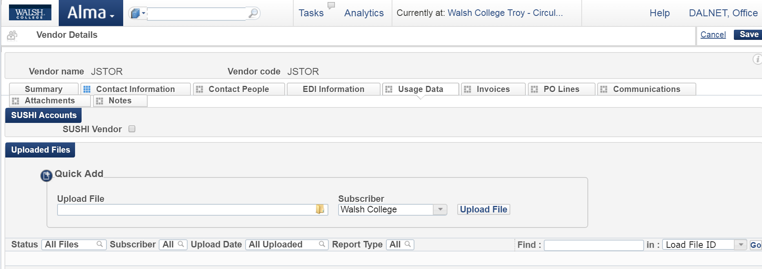

Click Add:
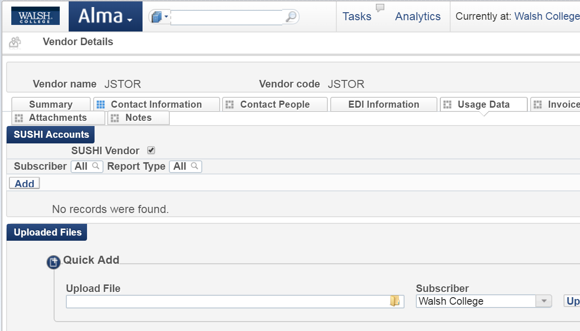

In SUSHI Account box, begin typing and after you enter three letters in this field a drop-down list of SUSHI-certified vendors appears (this is predefined by Ex Libris). If you select any of the vendors from this list, the Vendor URL is pre-filled with the correct URL for the vendor (other information will also be prefilled as well).

Note: you do not need to select a predefined certified vendor; you may enter any value you like as long as you have the information needed to continue filling in the account details.

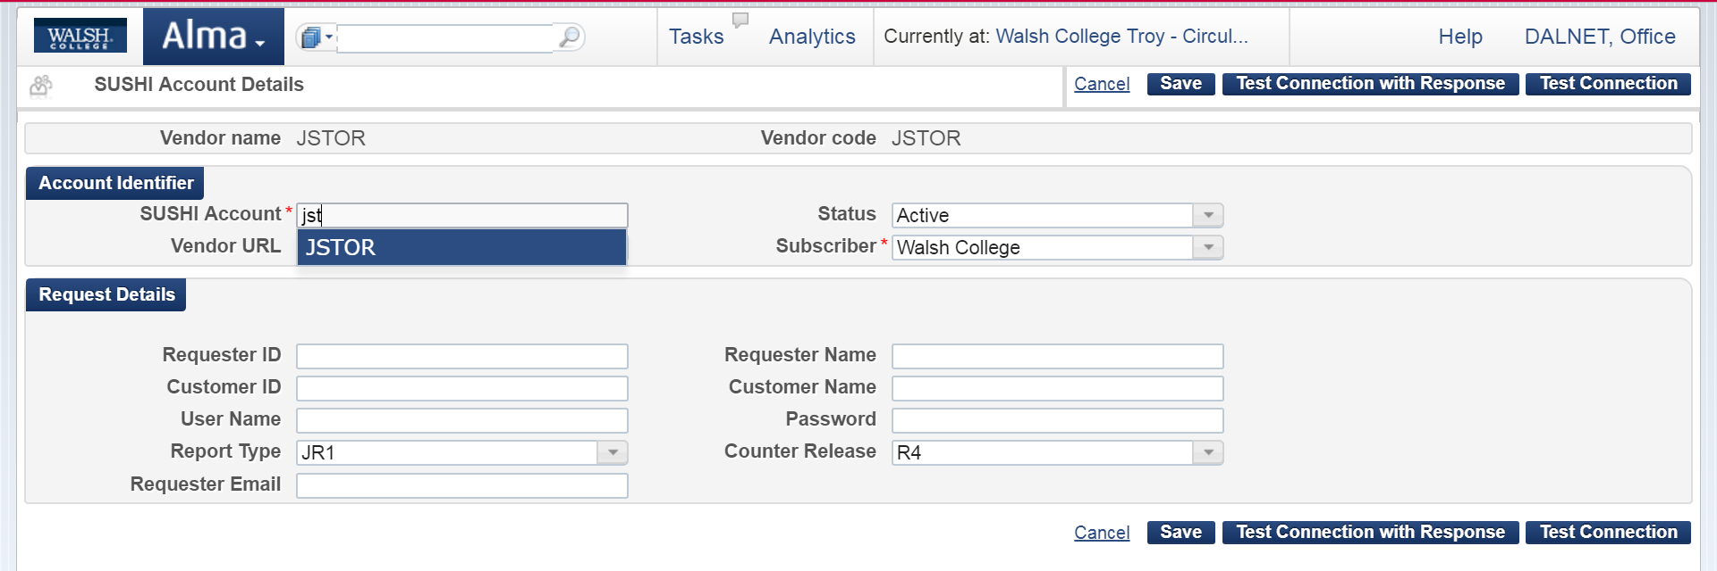

Fill in areas in red and anything else relevant to your vendor account. The current COUNTER Release is R4 which will be pre-populated for you.

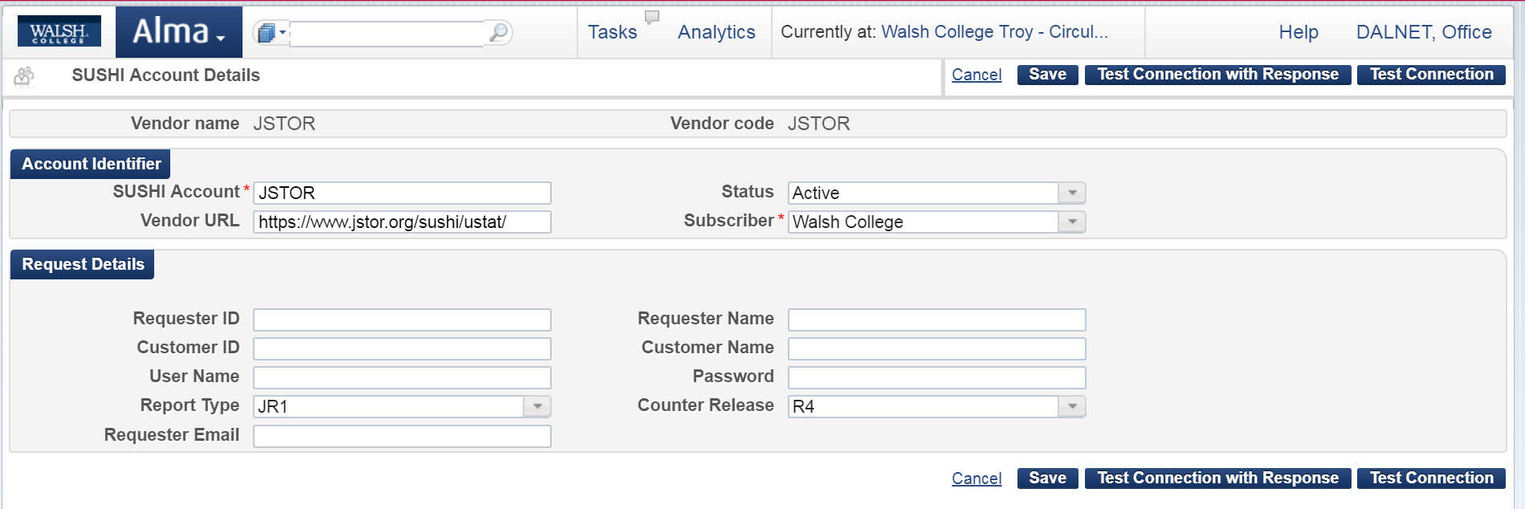

Test the connection by clicking on the Test Connection button. If there is an error, an error message appears at the top of the page. In this case, you may want to click Test Connection with Response to view a Zip file containing both the SUSHI request and response packages (in XML) sent to/from the vendor. If needed, send the file to dalnethelp@wayne.edu for assistance.

Click Save button if Test Connection succeeds.

COUNTER Report Types from Ex Libris Knowledge Center:

This has important information that you will reference often:
https://knowledge.exlibrisgroup.com/Alma/Product_Documentation/Alma_Online_Help_(English)/Acquisitions/090Acquisitions_Infrastructure/010Managing_Vendors/Managing_COUNTER-Compliant_Usage_Data#COUNTER_Report_Types

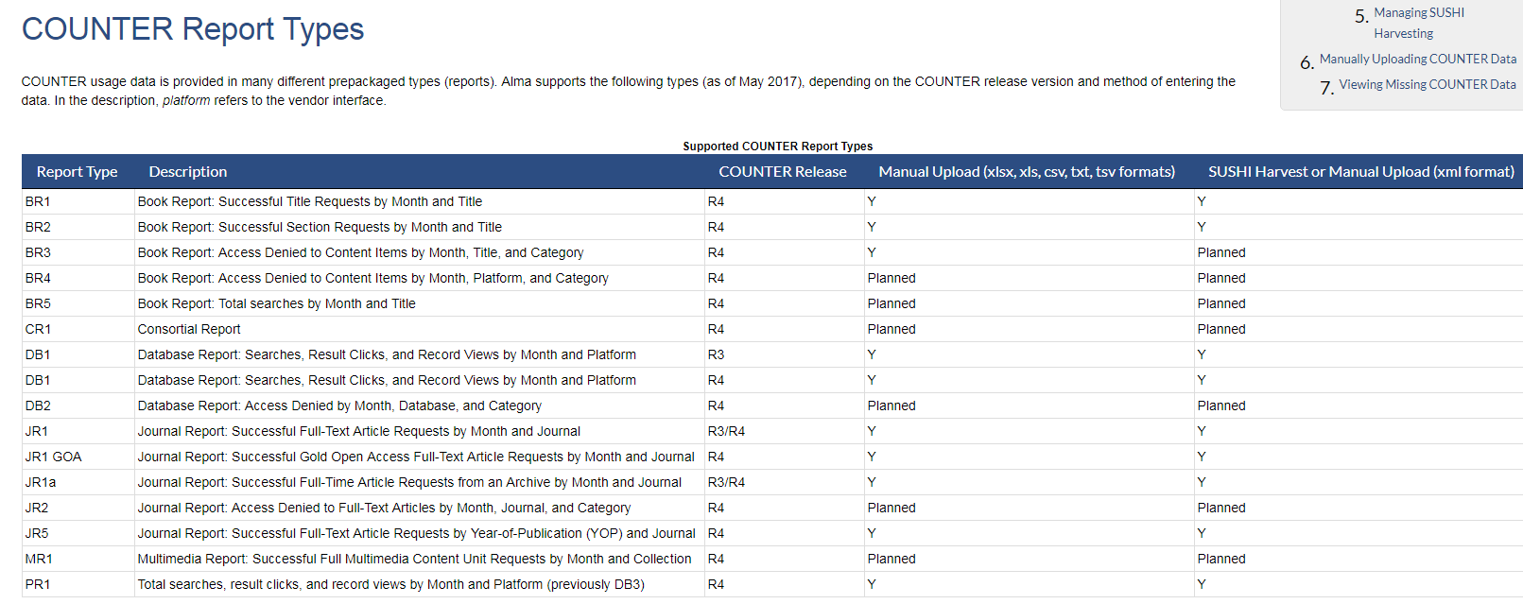

- Manually Uploading COUNTER Data

You must have the following roles to do this:
- Usage Data Operator
- Vendor Manager

Your vendor can supply you with COUNTER data for manual upload to Alma. The data must be in one of the following formats: xsls, xls, csv, txt, or tsv. For some report types, you can also manually upload data in xml format. Please see COUNTER Report Types on page 6.

Log into your vendor site to access the COUNTER Reports. For this example, I downloaded Book Report 2 and Platform Report 1 to a file on my desktop. Currently, Multimedia Report 1 is not supported in Alma per the table on page 6. Follow any instructions from the vendor. As shown below, I needed to “Enable Editing” as they instructed.

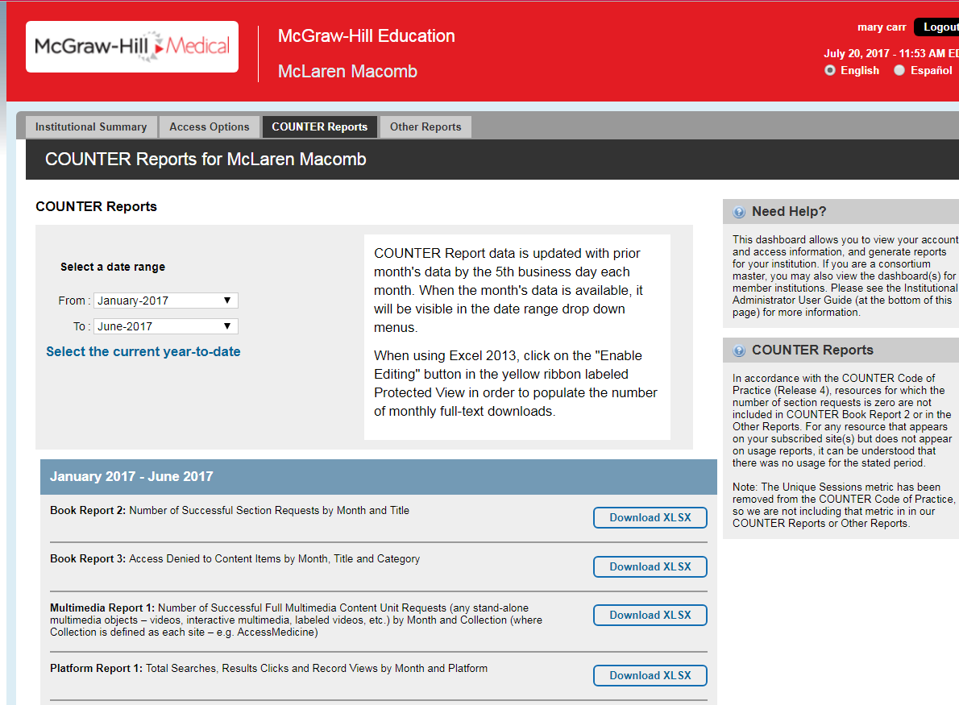

Continued on next page

Per Ex Libris, there are two ways to manually upload the information depending on what roles you have in Alma. Many of us have both roles; however, your staff may not, so this document will cover both ways to manually upload your COUNTER reports.

- Those with the Usage Data Operator Role
Path in Alma: Acquisitions > Import > Load Usage Data
Screenshot below is for path because it is confusing due to “Import” being in two areas.
Click on “Load Usage Data” under “Import” in black letters.

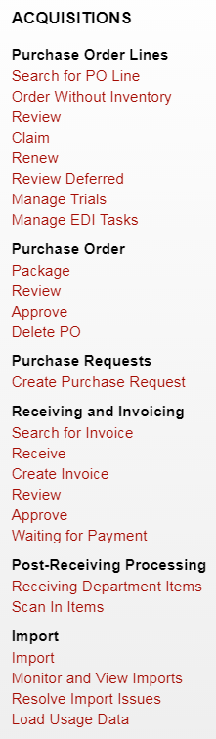

Click on blue arrow in Vendor box:

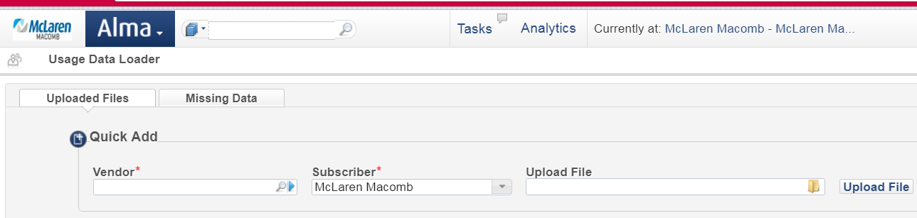

Search Vendors box appears. Click radio box next to the selected vendor.
Please note: If you have not yet added a Vendor and a Vendor Account, please see page 12.

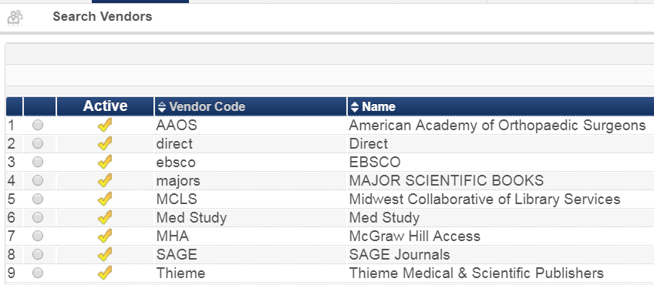

It will fill in the Vendor box. Next, in Upload File, click on the file folder to find the COUNTER file you saved from your vendor. Once you find and select it, click on Upload File:

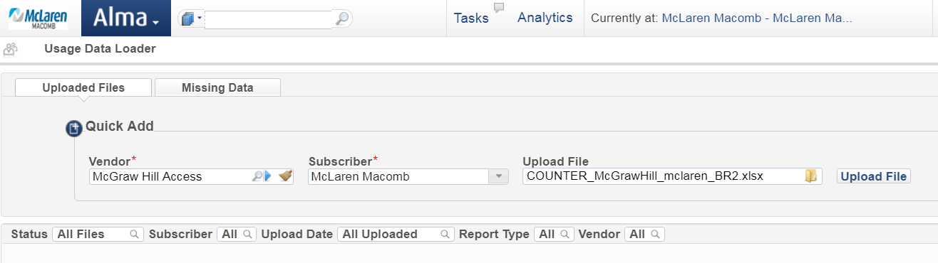

The file successfully uploaded per the status of Fully Processed:

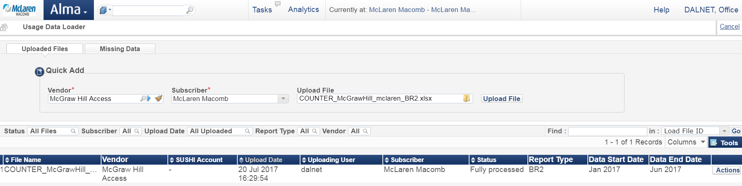

You may click on the Actions button to View or Download:

- Those with the Vendor Manager Role
Path in Alma: Acquisitions > Acquisitions Infrastructure > Vendors > [Select vendor] > Actions Button > Edit > Usage Data tab

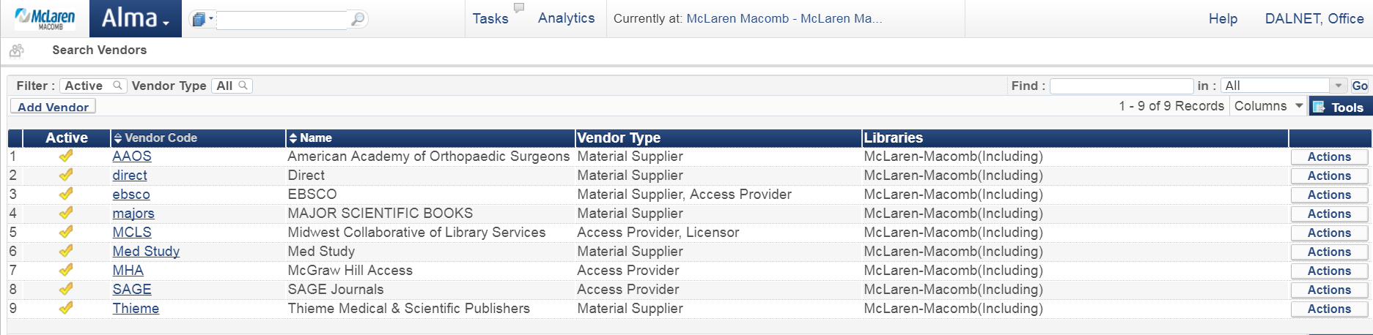

Continued on next page

Select Usage Data tab:

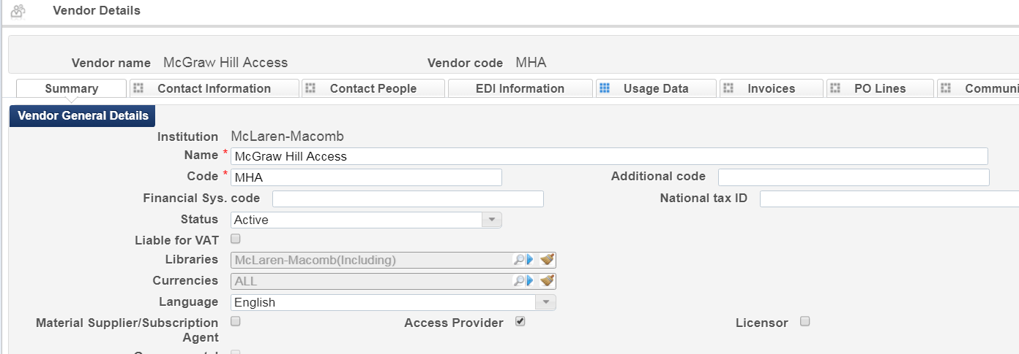

Click on Folder under Quick Add and select the COUNTER file you have saved and want to upload. Click Upload File:

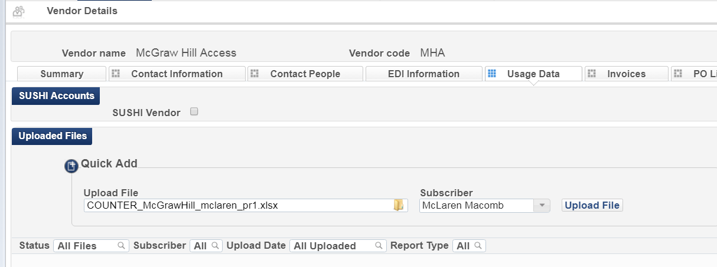

The file successfully loaded per the status message of Fully Processed:

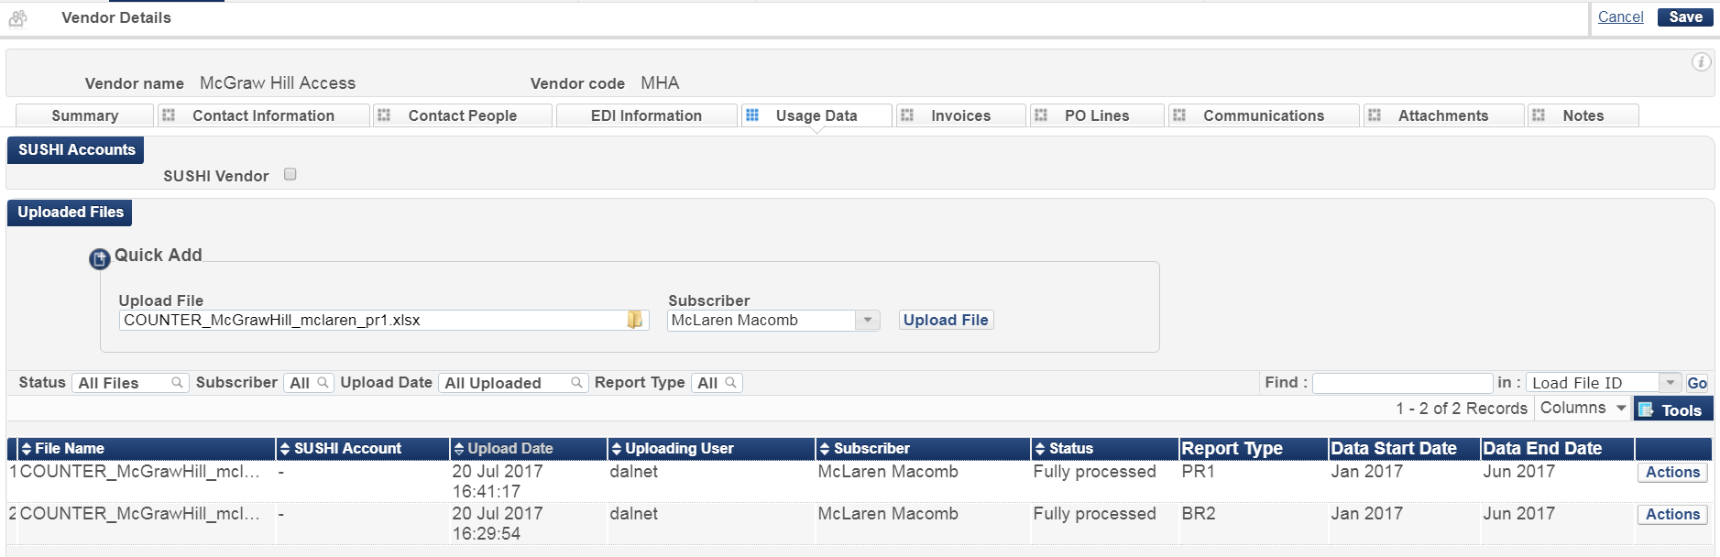

NOTE: You do not have to create a SUSHI account to retrieve COUNTER data from a vendor. Whether or not you configure a SUSHI account for a vendor, a vendor can provide you with COUNTER data by some other means for you (or the DALNET office) to upload manually into Alma.

- To Add a Vendor and a Vendor Account please view the following:

https://knowledge.exlibrisgroup.com/Alma/Product_Documentation/Alma_Online_Help_(English)/Acquisitions/090Acquisitions_Infrastructure/010Managing_Vendors#Adding_a_Vendor_and_Vendor_Account

