Footprints 4371
1. Health Affairs – 2 holdings for 1 bib:
When you see the above, this means the holding with no PO Line attached was created for the Horizon item that migrated.
I would go to Actions > View Items.
Then Actions > Withdraw. This will get rid of the item.
Then it will ask what you want to do with the holding record that item was attached to. Click “Delete the holdings record” and click Go.
Now the bib for Health Affairs has only one holding record attached with 6 items.

2. The American Surgeon:
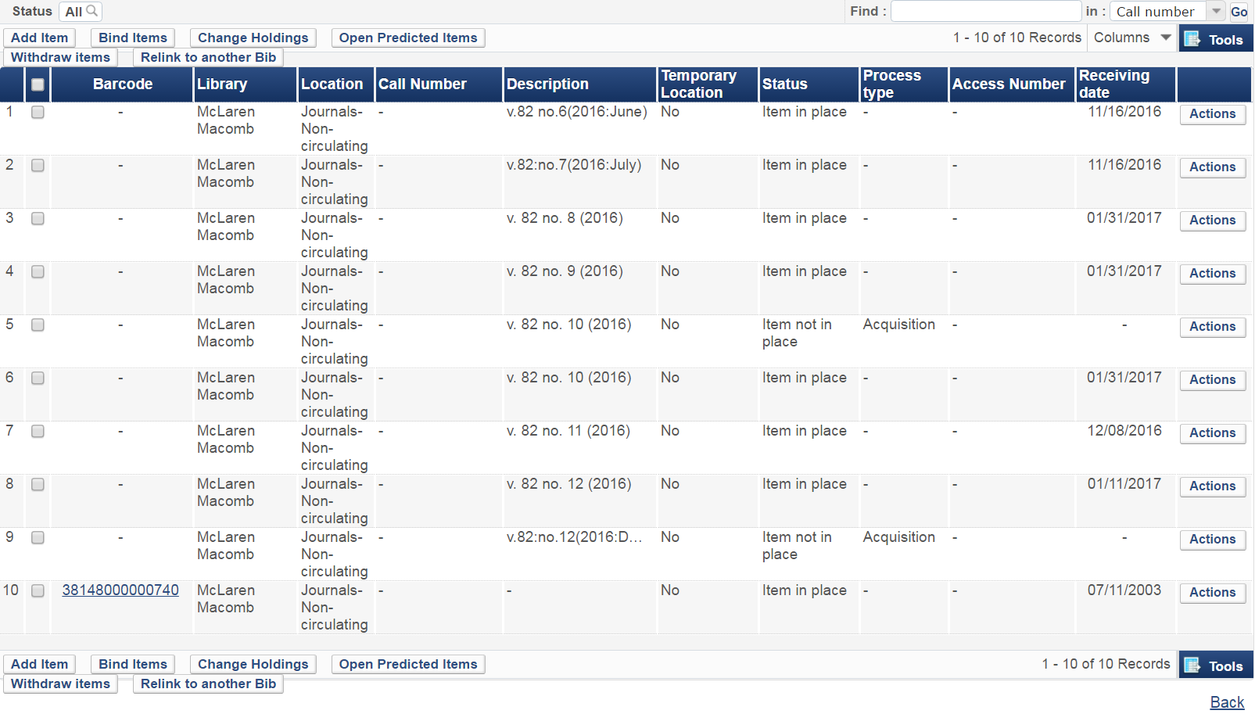
Since the items that are not in place and have an Acquisition process are duplicates of items that have already been received, I would delete them.
You do this by clicking the Actions button after the one you want to delete. Then click “Withdraw.” This will delete the item.

